Exploring Logarithmic Functions with Fractional Bases
Sheldon P. Gordon
SUNY Distinguished Teaching Professor Emeritus of Mathematics
Farmingdale State College
Farmingdale, NY 11735, USA
gordonsp@farmingdale.edu, 631-368-3781

Florence S. Gordon
Professor Emeritus of Mathematics
New York Institute of Technology
Old Westbury, NY 11568, USA
fgordon@nyit.edu 631-368-3781

Exploring Logarithmic Functions with Fractional Bases

In algebra and precalculus courses, four fundamental families of elementary functions are typically introduced – linear functions, exponential functions, power functions, and logarithmic functions. The usual approach is to focus on the behavioral patterns of each, particularly of the first three families, with emphasis on the significance of the associated parameters – especially the slope m of the linear functions y = mx + b, the base b of the exponential functions y = Ab^{x} (the so-called growth factor if b > 1 and the decay factor if 0 < b < 1), and the power p of the power functions y = Ax^{p}.
However, the logarithmic functions y = log_{b} x tend to get very short shrift in this kind of development; the only base usually considered at college algebra or precalculus level is base 10 and subsequently in calculus the base e for the natural logarithm is introduced. Instead, the focus rapidly shifts to the algebraic properties of the logarithm and this tends to continue throughout the subsequent calculus courses. While we often say that this algebraic property applies to logs with any base or that the behavioral property is that of an increasing, concave down function that passes through the point (1, 0) applies with any base, students never actually see that in action.
In this article, we explore the role of the base b in the behavior of logarithmic functions with different bases and, in particular, the behavior of log functions with fractional bases between 0 and 1, something which many mathematics educators are not familiar with. The investigations are conducted using dynamic software that bring the concepts to life when used for classroom demonstrations and so make a far more striking impact on students’ understanding of how logarithms behave. The authors [1] have previously addressed the use of dynamic software in providing a visual interpretation to almost all of the usual identities for exponential and logarithmic functions.
We also note that a great many of the mathematical models developed and used in the sciences and mathematics involve the use of log functions, so an understanding of their behavior is probably more important there than is familiarity with their manipulative properties.
Comparing Logarithmic Functions with Different Bases b > 1
We begin by looking at the graphs of log functions with different bases. Figure 1 shows the graphs with b = 2, b = 3, and b = 5. Clearly, all three curves are increasing and concave down, all pass through the point (1, 0), and all tend toward -∞ as x approaches 0. However, we suspect that most readers would have to pause and think if asked: Which curve is which? If that is the case, then we should not be surprised that most students would not be able to answer that fairly straightforward question. That means that additional specific attention needs to be paid to such issues in our courses.
To address this situation, the authors have developed a number of dynamic explorations in Excel that are intended for classroom demonstrations and for distribution to students to use on their own to explore the concepts in more depth. They are available, gratis, at https://pages.nyit.edu/fgordon/digmath-precalculus/.

Figure 1: Graphs of three log functions
Figure 2 shows the main screen of the first [2] of the dynamic spreadsheets mentioned. The three curves are the graphs of y = log _{1.5} x (in green), y = log _{2.4} x (in red), and y = log ₅ x (in blue). The blue and the red graphs are fixed in the sense that they are used as reference curves. The spreadsheet uses the slider at the upper left to allow the user to vary the choice of the base b used for the red curve, for values between 1.6 and 4.9, and the resulting chart changes essentially instantaneously, so that the image gives the impression of the red curve morphing smoothly from one position to another. Thus, students can see the dynamic variation in the curve as the value of b changes; the closer that b is to either 1.5 or 5.0, the closer the red curve is the corresponding reference curve. There is a second slider on the right that lets the user trace along the values of x to highlight the three corresponding points on the three curves (all in coordinated colors). Finally, the spreadsheet displays, again in coordinated colors, the numerical values associated with each of the three points.
Comparing Logarithmic Functions with Different Bases 0 < b < 1
We know that logarithmic functions and exponential functions are closely related and that the base b of an exponential function can be any positive number, though the behavior patterns change dramatically depending on whether b is greater than 1 or less than 1. We now consider what happens if the base for a logarithmic function is a fraction between 0 and 1.
Figure 3 is a variation [3] on the spreadsheet pictured in Figure 2; instead of allowing only values of b greater than 1, this spreadsheet accepts values that are between 0 and 1. In particular, the green and blue curves shown as references correspond to b = 0.1 and b = 0.9, respectively. The left-hand slider allows the user to select a value of b between 0.15 and 0.85, whose graph is shown in red. By far, the most notable aspect of these three graphs is that each of these logarithmic functions is decreasing and concave up. In addition, they also all pass through the point (1,0), and are all asymptotic to the positive y -axis as x approaches 0.

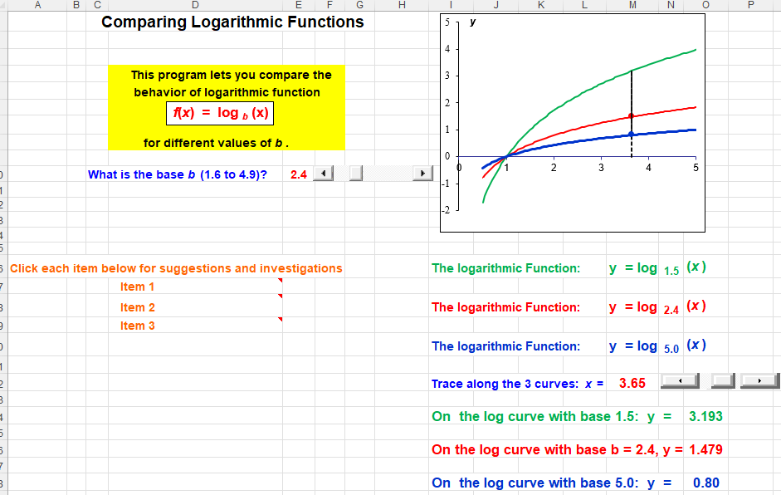
Figure 2: Three log functions with different bases
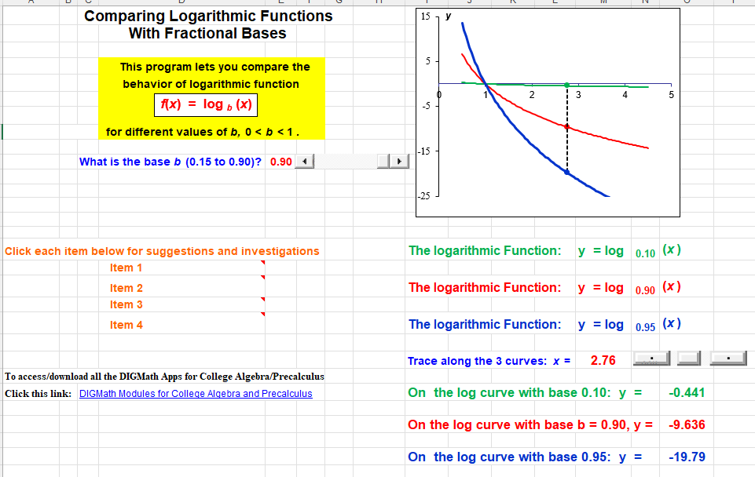
Figure 3: Three log functions with bases between 0 and 1

To understand this perhaps surprising behavior for log functions with base b < l, we use the formula for converting from one log system to another :
$\log_{b}{(}x)=\frac{\log_{c}{(}x)}{\log_{c}{(}b)}$.
In particular, to convert from base 10, this becomes
$\log_{b}{(}x)=\frac{\log_{}{(}x)}{\log_{}{(}b)}$ (1)
and to convert from natural logarithms,
$\log_{b}{(}x)=\frac{\ln{(}x)}{\ln{(}b)}$.
Since b < 1, log (b) < 0. Therefore, when x < 1, log (x) < 1 also, so that for any base b between 0 and 1, log _{b} (x) must be positive. On the other hand, when x > 1, log _{b} (x) will be negative. Moreover, whenever x > 1, log _{b} (x) will be positive. Furthermore, since log (x) is asymptotic to the positive y-axis, log _{b} (x) must be asymptotic to the negative y-axis. Finally, as x increases beyond x = 1, log (x) grows ever more slowly and hence log _{b} (x) will decay ever more slowly through negative values.
We note that this is a very effective way of re-enforcing some important ideas for students in a way that is not simply a review of the topics.
Incidentally, to see where the conversion formulas come from, suppose y = log _{b} (x), so that x = b^{y}. Taking logs of both sides to base 10, we find that
log (x) = log (b^{y}) = y log (b) = y = log _{b} (x) log (b).
Dividing by log (b) produces Equation (1).
We can use the same line of reasoning applied above to demonstrate that other fundamental properties of logarithms with base b > 1 also hold when 0 < b < 1. For instance, consider the identity log (x^{p}) = p log (x). We have
log _{b} (x^{p}) = log (x^{p}) / log (b) = p log (x) / log (b) = p log _{b} (x^{p}).
Similarly,
log _{b} (uv) = log (uv) / log (b) = [log (u) + log (v)]/ log (b) = log _{b} (u) + log _{b} (v).
We leave it to the interested reader to verify that other properties of logarithms likewise carry over to logs with bases between 0 and 1.
As another perspective on these ideas, we consider how the values for log _{b} (x) behave as a function of the base b (rather than the variable x) when b is between 0 and 10. That is, for any given value of x, we look at the values of log _{b} (x) for each of a reasonably large number of values of b. The graph of this function is shown in Figure 4. The graph is very suggestive of a logarithmic function with a base greater than 1. The tracing point shown corresponds to b = e ≈ 2.718… and, by eye, the associated height is close to 1, which is what we should expect. Similarly, if we were to trace to b = e² ≈ 7.388, the associated height would be 2.
We note that the above perspective is likely too sophisticated for all but the very best students in a college algebra or precalculus course and therefore we would not recommend that it be included in such a course.
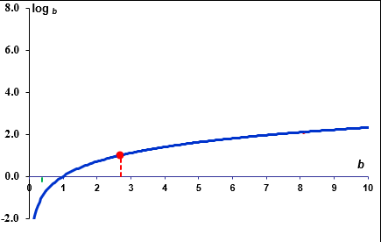
Figure 4: log _{b} (x) as a function of the base b

Symmetry of Logarithmic Functions and Exponential Functions with Bases b < 1

Our final perspective on logarithmic functions with fractional bases has to do with the concept of inverse functions and the fact that the graphs of a function and its inverse are mirror images of one another across the diagonal line y = x. Typically, this is illustrated in class with one or perhaps two examples in which the associated graphs are drawn on the board. Unfortunately, hand-drawn graphs that are reasonably accurate are difficult to draw free-hand, are very time-consuming to construct with any accuracy, and often do not have great impact on students.
To avoid these difficulties, the authors have developed another dynamic spreadsheet based on the exponential function y = b^{x} and the associated inverse function y = log _{b} (x), with values of b between 0 and 2 that can be selected using a slider. Also, the user can trace along the two curves. A typical display, where the value chosen for the base is between 0 and 1, is shown in Figure 5. Notice that the horizontal and vertical distances from the curves to the line are drawn in corresponding colors. The associated numerical values are also displayed to demonstrate clearly that the distances are always the same and so the two curves are indeed mirror images across the line. The dynamic nature of the spreadsheet provides a simple way to show literally thousands of slightly different images in an animated fashion that gives a much more convincing demonstration of the concept compared to the static image of a single hand-drawn graph.
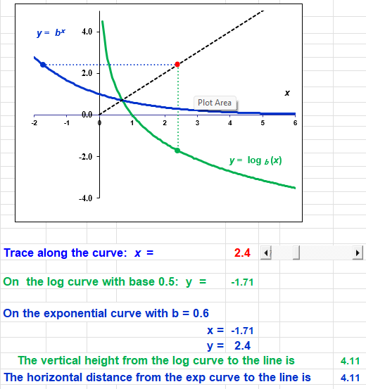
Figure 5: Symmetry of the Inverse Functions y =log _{b} (x) and y = b^{x}

Classroom Experiences
Fifty years ago, faculty in most other quantitative disciplines used to disparagingly talk about the half-life of mathematics students being one-semester. In reality, in most math courses, including the authors’, roughly 50% of the students who started any course received a passing grade, and this was typical in most institutions; often, the results were much worse. The authors recall one colleague who started a course in differential equations with 24 students only one of whom received a passing grade and that professor said that he had passed that student only out of mercy!
However, these results were actually worse than these percentages would indicate. All of these courses were intended to prepare students for the subsequent course, but a significant number of those who did achieve a passing grade did not continue on to the following course. That loss tended to be hidden by “new” students who were taking the successive mathematics courses having had more math in high school or who were transferring in from another institution. Thus, the actual loss was usually well above the 50% level.
In response to these abysmal results, the authors began developing sophisticated graphical programs to demonstrate mathematical ideas and techniques for classroom use. These programs started originally with calculus and statistics and then extended to differential equations, precalculus, numerical methods, and so on over the past 45 years. Originally, the programs were done on a mainframe using Tektronix graphing terminals, then redone for the PC using BASIC, and eventually redone again in Excel to make use of the special built-in capabilities to introduce dynamic components for the input of data and the resulting graphical images.
From the beginning, it was evident that student interest and understanding improved and their results on tests, written work, and overall performance and persistence in any of the courses improved significantly. In fact, the more frequently such software was used in these courses, the greater the improvement and, interestingly, the less time needed for each subsequent demonstration because the students were increasingly familiar with the mechanics. In particular:
- There was a greater persistence on the part of students to stick with the course(s). Previously, a fairly substantial number of students would fall behind and drop out between the fourth and eighth weeks. With the change in emphasis due to the technology, there were fewer drop-outs and most of those occurred between the eighth and twelfth weeks.
- Overall, there seemed to be better performance on tests, which was somewhat counter-intuitive. The emphasis in the courses shifted more toward conceptual understanding and much more realistic applications usually focused on real-world data and the creation of mathematical models and less on the development of routine algebraic skills. In turn, the tests reflected the new emphases with questions demanding understanding of the key concepts and their interpretations and others requiring the creation of mathematical models to mirror sets of data and predictive questions requiring solving much more sophisticated equations than the routine ones. Furthermore, unlike traditional problems, students could not simply try to memorize a bunch of solutions to template examples and merely expect the numbers to change. Yet, without being presented with long sets of routine exercises to practice, they were able to handle the considerably more complicated equations. Perhaps the non-routine nature of the applied problems encouraged them to work at homework problems more intensively and so better learned the mechanics. And, once they realized that they actually had to learn the concepts and think, most were well prepared for problems of a conceptual nature.
- There was a clear improvement in the overall course performance. Very few students received failing or unsatisfactory grades in the course. In one of the last precalculus courses offered prior to retirement, only one student failed the course (with an average of perhaps 40) and only a handful of students who had dropped out along the way.
- In a study conducted by an external evaluator, a comparison was made between students taking traditional precalculus sections and those taking the reform versions. The initial results on the placement test indicated those students in the traditional sections had, on average, better algebraic skills. The study involved using a common final exam for all sections; however, the instructors teaching the traditional sections felt their students would be at a distinct disadvantage if the applied problems were non-traditional (no one seemed to realize that this would put the students in the reform sections at a distinct disadvantage). Surprisingly, the students in the reform sections scored better on almost every traditional, skill-oriented problem than those in the traditional sections.
- In the study, it was found that a statistically significant larger percentage of the students from the reform sections went on to start calculus 1. Moreover, a statistically significant larger percentage of the students who had been through the reform precalculus approach successfully completed the first semester of calculus compared to the students who had been through a traditional precalculus course.
- There was quite a dichotomy between the attitudes toward the version of the precalculus course the students took. Typical comments from those in the traditional approach included: “I didn’t really use the textbook unless to do homework”, “It was your average boring textbook for any math course”, “Sort of stuff I did in high school”, “Certain topics which I couldn’t understand previously became clear to me and turned out to be very interesting”, “The least interesting was logs”, and “The importance of math is to be able to solve day to day problems and figure things out in your normal life”. In comparison, comments from the students in the reform course included: “The text is interesting because it deals with interesting math problems we encounter in life”, “I like the Data Analysis the best because it was interesting to take a table of values and apply formulas to them. Least interesting was trig identities.”, “I found how math can be applied to everyday problems. Previously, I hardly ever found a use for much of the math I learned.”, “I feel I can do more with mathematics now.”, “Mathematics is the most important subject because it deals with problem solving, just like architecture.”, and “Math is a part of life – everything we experience, whether tides or hour of daylight or population growth or rising medical costs, deals with math. I now have a much better understanding of the patterns of life and how math can be applied to them..”

Concluding Remarks
Comparable modules to the ones described here can certainly be developed with other specialized software platforms such as GeoAlgebra or Geometer’s Sketchpad or possibly even with TI and other graphing calculators. However, we believe there are some fairly strong reasons to use Excel. First, Excel is almost universally available versus specialized mathematics packages. Certainly, if students were to use dynamic software in a public library or other setting outside of the actual mathematics classroom, Excel would almost certainly be available, but not any specialized software. Second, Excel is the computational platform across almost all other quantitative disciplines other than mathematics, so students will be much more likely to be familiar with it from their other non-math courses. Third, unless students come into a particular math class from a preceding course that also used one of these specialized software packages, they will be totally unfamiliar with the software platform and it would take lots of valuable class time to get them familiar and comfortable with using it. On the other hand, it is the authors’ perception that most student are exposed to Excel as early as even intermediate school (at least in the U.S.), though not necessarily in math classes, so they are already familiar and comfortable using spreadsheets, even if only at the most rudimentary level. However, that is all that is required to use the authors’ dynamic software – the lowest level of familiarity with Excel.
As far as graphing calculators are concerned, while excellent programs are available to demonstrate mathematical concepts and methods graphically and somewhat dynamically, there is always the limitation on the level of resolution on the very small screen. Moreover, there are definite speed limitations with using such calculators that make using them dynamically somewhat of a challenge, to put it mildly.
In conclusion, we feel that the ideas developed here would make a nice addition to the standard curriculum that would provide students with an introduction to a broader view of logarithms while simultaneously providing a nice opportunity to reinforce some fundamental concepts on the behavior of functions in general and logarithms in particular. We consider this preferable to a bland review of many of the same topics done purely as review. Moreover, the dynamic nature of the software means that the topics can be treated in very little time compared to more traditional blackboard presentations of mathematics. Finally, introducing ideas that are outside the usual textbook treatments can have the positive effect of demonstrating to students that mathematics is a living subject that is much more than a bunch of topics discovered hundreds of years ago and, as the authors have found, inspire many of them to pursue mathematics.

References
- Gordon, Sheldon P. and Florence S. Gordon, Visualizing and Understanding Exponential and Logarithmic Identities Using Dynamic Software, submitted.
- Gordon, Sheldon P. and Florence S. Gordon, Comparing Log Functions with Different Bases, dynamic spreadsheet, currently #25 , https://pages.nyit.edu/fgordon/digmath-precalculus/
- Gordon, Sheldon P. and Florence S. Gordon, Comparing Log Functions with Fractional Bases, dynamic spreadsheet, currently #26 , https://pages.nyit.edu/fgordon/digmath-precalculus/.
- Gordon, Sheldon P. and Florence S. Gordon, Symmetry of Inverse Functions, dynamic spreadsheet, currently #58 https://pages.nyit.edu/fgordon/digmath-precalculus/ed.

