Title Page
Using Moving Averages to Find Trends in Data
Sheldon P. Gordon Florence S. Gordon
Farmingdale State College New York Institute of Technology
Contact Information Sheldon P. Gordon, SUNY Distinguished Teaching Professor Mathematics (emeritus), Farmingdale State College, Broadhollow Road, Farmingdale, NY 11735, USA, gordonsp@farmingdale.edu, 631-368-3781
Florence S. Gordon, Professor of Mathematics (emeritus), New York Institute of Technology, Old Westbury, NY, 11568, fgordon@nyit.edu
Biographical Sketches
Shelly Gordon is SUNY Distinguished Teaching Professor of Mathematics at Farmingdale State College in New York, USA. He has been deeply involved in efforts to revitalize the undergraduate mathematics curriculum at all levels ranging from algebra, precalculus, calculus, differential equations, and statistics and probability, particularly from the perspective of the use of technology to enhance student understanding of mathematical concepts and methods. Shelly has authored about 225 papers, a dozen textbooks and monograph volumes, and hundreds of software programs for mathematics education that bring the concepts and methods alive for students via dynamic graphical and numerical perspectives.
Flo Gordon is Professor of Mathematics (emeritus) at New York Institute of Technology in Old Westbury, NY, USA. She is a co-author of Functioning in the Real World and Contemporary Statistics: A Computer Approach and co-editor of the MAA volumes, Statistics for the Twenty First Century and A Fresh Start for Collegiate Mathematics: Rethinking the Courses Below Calculus. She is also the author of about 80 papers on mathematics and statistics education. She has been very involved in efforts to improve the teaching of mathematics at all levels, with special emphasis on statistics and precalculus education.

Abstract
This article introduces the notion of the moving averages in a set of data in which there is very significant variations in the values from day to day as a way to smooth out the data. The technique is very widely used in medicine and business/finance, but is not widely known among the general population. The article focuses on how to calculate and visualize moving averages, comparing moving averages based on the number of days used, and finding the best trend in both the original data and the associated moving averages from the usual families of functions – linear, exponential, power, quadratic, and cubic. Dynamic visualizations are used throughout to demonstrate how the concepts arise and how to improve student understanding of them.

Keywords: moving averages, fitting functions to data, dynamic visualizations

Using Moving Averages to Find Trends in Data
Whether in an introductory statistics course or a modern college algebra or precalculus course that focuses on functions, data, and modeling, one of the most important topics is that of fitting functions to real world data, particularly with linear regression. Often, the data set is reasonably small and the points fall into a fairly distinct and recognizable pattern.
However, there are significant applications in which the data set is rather large and there is so much variation among the data points that it is not so obvious what the underlying pattern might be. This is particularly true with many applications in business and finance, where one often looks at the daily prices of a stock, say, or interest rates, where there can be drastic day-to-day fluctuations that make it quite difficult to ascertain the pattern, particularly to the uninformed eye. And, the reality is that learning how to deal with such situations, often known as time-series analysis, is not introduced until advanced statistics courses for business or other majors. The specific tool used in such a context is what is called moving averages, such as the 10-day moving average or the 30-day moving average. Decisions on whether to buy or sell are often based on when the current day’s price falls below or breaks above the associated moving average.
The same kind of situation also arises in medicine and the health sciences. For instance, for the past two years and more, we have been bombarded on a daily basis with charts such as the one shown in Figure 1, giving the daily total of new cases of COVID 19 diagnosed each day in, say, New York State since the start of the pandemic in early 2020. But, these data values display an incredible degree of fluctuations as they increase or decrease by the hundreds (when the pandemic was seemingly almost over) or by the tens of thousands (during some of the very sharp spike or surge periods). Because of this, medical professionals employ charts showing the 7-day moving averages, such as that in Figure 2, and these charts are the ones primarily available in the media today. But, nowhere in the charts is there any explanation of what “7-day moving averages” means.
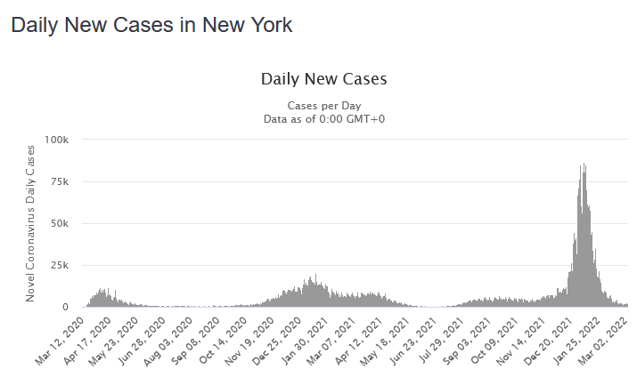
Figure 1: Daily New COVID cases across New York State

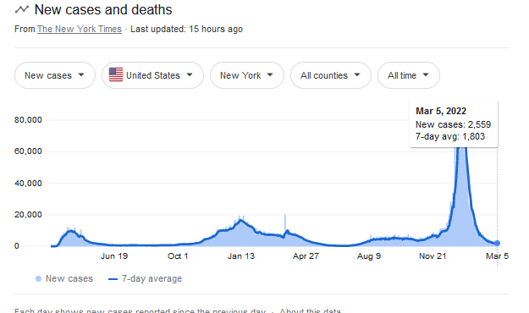
Figure 2: 7-Day Moving Averages of Daily New COVID Cases across New York State

Clearly, the idea of a moving average has become increasingly important and is a key to making informed and rational decisions about essential issues. Yet it is something that the overwhelming majority of the population has never been introduced to formally. And without that understanding, most people who see such a display have no idea what information is being provided.
As such, it becomes incumbent on the mathematics profession to view this as an opportunity to find ways to incorporate moving averages into our lower-division curriculum to bring it to the attention of a very wide audience, especially if it can be done in ways that are both natural and appropriate while serving to reinforce other important topics in those courses. The present authors believe that both introductory statistics courses and appropriately-themed college algebra or precalculus courses provide the ideal venues for doing this.

How Do You Calculate the Moving Average?
Suppose you have the following data, recorded on a daily basis, that displays very large daily fluctuations.
Day | 1 | 2 | 3 | 4 | 5 | 6 | 7 | 8 | 9 | 10 | 11 | 12
Value | 100 | 80 | 130 | 110 | 150 | 60 | 120 | 90 | 140 | 160 | 90 | 140
We show the scatterplot for this data in Figure 3. Suppose we want to calculate the 5-day moving averages. The first of these is the mean of the first five entries, or (100 + 80 + 130 + 110 + 150)/5 = 580/5 = 116. It is typically recorded in the 5th column as shown in the table below. The previous entries in that row for the moving averages, MA’s, are usually recorded as NA,. The following moving average is based on the 2nd, 3rd, …, 6th entries, so is (80 + 130 + 110 + 150 + 60)/5 = 530/5 = 106, and so forth. (Note: This is not the next distinct grouping of five entries, but just shifted one further along from the previous grouping, which is why it is described as a moving average.)
Day | 1 | 2 | 3 | 4 | 5 | 6 | 7 | 8 | 9 | 10 | 11 | 12
Value | 100 | 80 | 130 | 110 | 150 | 60 | 120 | 90 | 140 | 160 | 90 | 140
MA’s | NA | NA | NA | NA | 116 | 106 | 110 | 124 | 112 | 114 | 120 | 124

Figure 3: Graph of the Data Figure 4: Graph of the Data and Moving Averages

Either from the entries in this table or from the graph in Figure 4, it is evident that the points for the moving averages have significantly less fluctuation on a day-by-day basis. As a consequence, it is considerably easier to spot a pattern in these points, which is the primary goal of using moving averages.
When dealing with large sets of data, it is helpful to automate the computation. For instance, there is a command in Excel to calculate all the moving averages associated with a list of data values in either a row or a column. This feature is found as part of the Data Analysis collection in the Analysis ToolPak. To access it, you click on Data and then select Data Analysis. If the Data Analysis collection is not showing, you will need to install it. Click on File, then click Options, and then select Add-Ins. Under Manage, select Excel Add-ins and click on Go. In the Add-ins box, check Analysis ToolPak and then press OK. To compute the moving averages, select Data and then Data Analysis, and finally Moving Averages. You then have to specify the location (the row or column) where the data is listed, the length of the interval (say, 5 for 5-day moving averages), and also the cells where the list of moving averages will appear – probably in the adjacent column or adjacent row to the data values.

Comparing Moving Averages Based on Different Time Intervals
As we mentioned in the Introduction, the purpose of using moving averages is to smooth out the day-to-day variations in a set of data. The natural question, though, is which time period does it make sense to use? From a practical perspective, with shorter-term data, such as the number of new COVID cases, the most common time period used is by the week, so that 7-day moving averages are typically used. With longer term data, such as financial data that might extend over many years, one might prefer to look at month-long intervals and so 30-day moving averages are often used.
However, a deeper aspect to this question is: what differences, if any, arise with different time periods? Or, if one is primarily interested in smoothing out the data as much as possible, is it preferable to use a shorter time period or a longer time period? To explore these questions, the authors have developed a dynamic spreadsheet in Excel to allow interested readers and their students to explore visually how the different moving averages compare to one another. (This spreadsheet, as well as others to be discussed later in this article, are available gratis; simply contact the authors.)
This spreadsheet uses actual data on the number of daily new COVID cases in New York State for a five-month period during the very early stages of the pandemic. We show the spreadsheet’s primary screen in Figure 5. The program creates the scatterplot of the data drawn in blue, draws the 3-day (in green) and the 20-day moving averages (in purple). It also allows the user to select any intermediate time interval (from 4 days to 19 days and plotted in red) to see how the different moving averages compare to one another and the extent to which they tend to smooth out the data. The slider allows the choice of the time interval to be made in such a way that the corresponding set of moving averages seem to “move” quite smoothly from one extreme to the other. That is, the closer that the choice for the time interval is to 3, the closer the corresponding moving averages are, in general, to the 3-day moving averages; the equivalent is true near the other extreme with the 20-day moving averages. Furthermore, typically, the shorter the time interval, the more the resulting curve for the moving averages oscillates up and down; at the other extreme, the longer the time interval, the less oscillation there is in the moving average curve. This point strongly dramatizes the statement that the moving averages tend to smooth out the variations in the data.
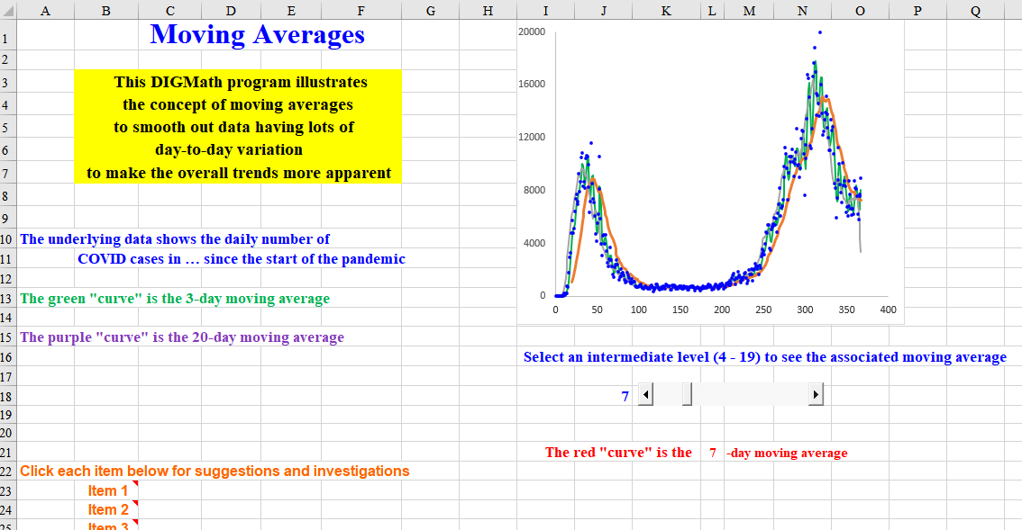
Figure 5: Spreadsheet for Comparing Moving Averages

Finding the Best Trend in the Data and the Moving Averages
We start by considering the simple example from above. The associated 5-day moving averages are also included in the table below and indicate far less extreme variation than the original values do. We also show the corresponding scatterplot in Figure 6 and observe that the overall patterns in both the data (in blue) and the moving averages (in red) might be linear, although the fluctuations in the original data may make that presumption somewhat iffy. The regression lines to the original data and to the moving averages are also included.
Day | 1 | 2 | 3 | 4 | 5 | 6 | 7 | 8 | 9 | 10 | 11 | 12
Value | 100 | 80 | 130 | 110 | 150 | 60 | 120 | 90 | 140 | 160 | 90 | 140
MA’s | NA | NA | NA | NA | 116 | 106 | 110 | 124 | 112 | 114 | 120 | 124

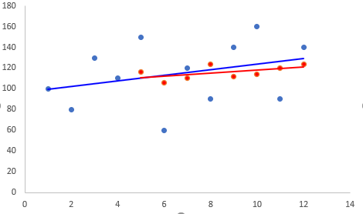
The equation of the regression line to the data is y = 2.6923x + 96.667 and the associated correlation coefficient is r = 0.3159. However, the critical value at the 5% significance level is r = 0.4973 and so we would conclude that there is no significant correlation; the choice of a linear function to capture the trend is not a good one. Similarly, the equation of the regression line to the moving averages is y =1.5x + 103 and the associated correlation coefficient is r = 0.5617, which is substantially larger than that for the original data. However, the critical value at the 5% significance level is now r = 0.6215; there are fewer points (n = 8 moving averages) and therefore the level of correlation needed to conclude significance is higher. Consequently, we again conclude that there is no significant linear correlation. Figure 6: Regression Lines for Both Sets of Data
In our discussion in the previous section, we saw that increasing the length of the time interval for the moving averages seemed to smooth out the data more and more. Let’s see what happens if we change from 5-day moving averages to 7-day moving averages, as shown in the following table.
Day | 1 | 2 | 3 | 4 | 5 | 6 | 7 | 8 | 9 | 10 | 11 | 12
Value | 100 | 80 | 130 | 110 | 150 | 60 | 120 | 90 | 140 | 160 | 90 | 140
5-MA | NA | NA | NA | NA | 116 | 106 | 110 | 124 | 112 | 114 | 120 | 124
7-MA | NA | NA | NA | NA | NA | NA | 107.14 | 105.71 | 114.29 | 118.57 | 115.71 | 114.29
The associated regression lines are shown in Figure 7. The equation of the regression line to the 7-day moving averages (in red) is y = 2x + 93.62 with an associated correlation coefficient of r = 0.739. However, the critical value at the 5% significance level is r = 0.7293, based on the n = 6 points, and so we would conclude that there now is significant correlation.
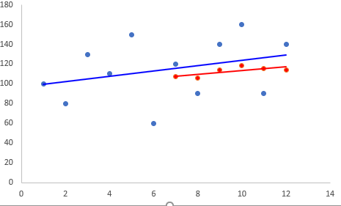
However, there are dangers involved if the above “strategy” of increasing the length of the intervals for the moving averages is continued too far. For instance, if we were to push it to 11-day moving averages, then there would be just two such moving averages for our set of 12 data points. Those two values precisely determine a linear function and so the correlation coefficient will always be 1 precisely. Figure 7: Regression Lines with 7-Day Moving Averages
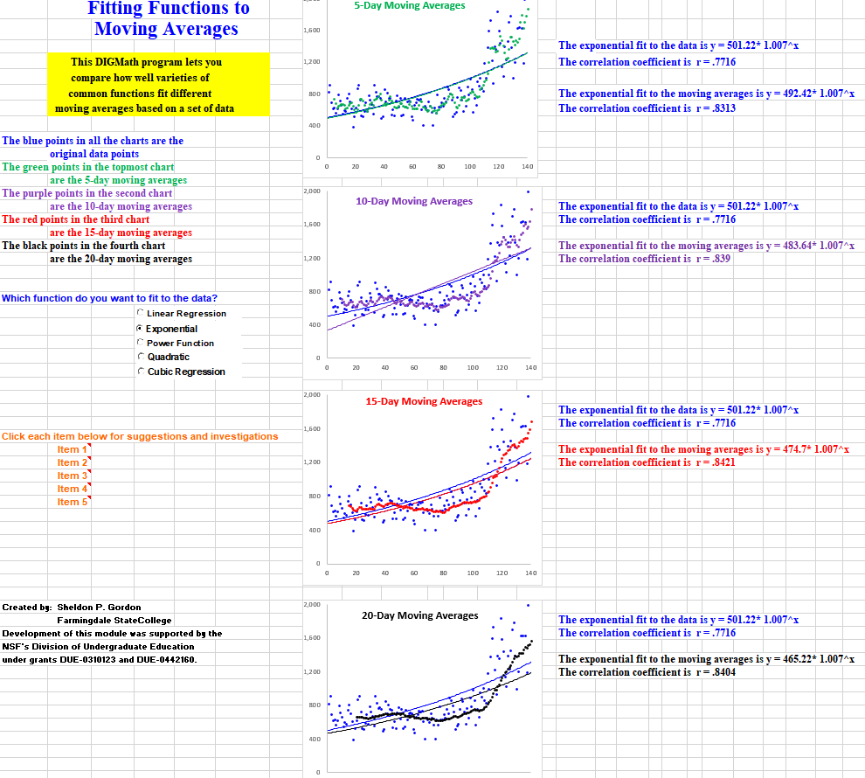
We now turn to a significantly more substantial example to illustrate the concepts involved in using moving averages to find the trend in a reasonably large set of data. We use the data on the daily number of new cases shown in Figure 1. To facilitate this investigation, the authors have developed a different dynamic spreadsheet that simultaneously displays four charts, each showing the number of new COVID cases in New York State each day over a 150-day period near the beginning of the pandemic. Figure 8 shows the associated display sheet. In each of the four charts, the actual data points are drawn with blue dots. The first chart also displays the associated 5-day moving averages (drawn in red); the second chart shows the 10-day moving averages (drawn in purple); the third chart shows the 15-day moving averages (in red); and the fourth chart shows the 20-day moving averages (in black).
Figure 8: Fitting Functions to Moving Averages

In addition, the spreadsheet gives the user the choice of the type of function to fit to the underlying data – linear, exponential, power, quadratic, or cubic. The one chosen is graphed in blue in each of the four charts. Further, the spreadsheet displays the comparable graph of the regression function of the selected family that is the best fit to the associated set of moving averages using the matching color.
Finally, the spreadsheet also prints out the equation of each of the two regression functions in each chart and the corresponding correlation coefficient r (if the function chosen is linear, exponential, or power) or the coefficient of multiple correlation R (if the quadratic or cubic function is selected).
To increase their understanding of the concepts, students are asked questions such as:
- By comparing the four charts, does there appear to be greater smoothness for the longer term (15- or 20-day) moving averages than for the shorter term (5- or 10-day) moving averages?
- Are there some functions that, by eye, seem to give much better agreement between the regression curve for the original data and the one for the moving averages? Are there functions that seem to give poorer agreement?
- Do the values of the correlation coefficients indicate better or worse fits as the number of days increases in the moving averages?
- Does any one family of functions appear to be a better fit to the original data for most or all of the moving averages? A worse fit?
- Does any one family of functions appear to be a better fit to the moving averages for most or all of the different time periods shown? A worse fit?
- Do your answers change depending on the kind of regression function you are using?
- Do you think your answers would likely remain the same for most other sets of data? Will they likely change?

Suggestions for Implementation
As mentioned at the beginning, the concept of moving averages can be introduced either in an introductory statistics course or a modern college algebra or precalculus course that focuses on applications and fitting functions to data. In the statistics course, this can be done in about 15 to 20 minutes, especially by using the first spreadsheet to do the calculations and display the result, all in conjunction with a discussion of linear regression. This provides a nice way of re-enforcing the notion of the mean of a set of data. Of course, in such a setting, one would not be introducing any of the non-linear curve-fitting ideas, so only the first investigation described above would make sense.
In a college algebra or precalculus course, these ideas would fit in nicely after having introduced the notion of fitting non-linear functions to data (once all the appropriate families of functions have been discussed). It would provide an opportunity to summarize the behavioral characteristics of each family while connecting those ideas to some of the fundamental statistical concepts, such as the mean and the correlation coefficient. This would likely entail using both of the spreadsheets described above for the calculations, the display, and the dynamic investigation of the comparisons between the different families of functions. Moreover, reviewing the different families of functions in a totally new context serves to remind the students of the key idea, as well as integrating statistical concepts into the main thread of the course. All of this can be done in under an hour.

