Visualizing and Understanding Exponential and Logarithmic Identities Using Dynamic Software
For the past 30 years, the major tenet of the undergraduate mathematics reform effort in the United States has been the so-called Rule of Three. This states that every topic should be treated numerically, graphically, and symbolically to reflect the fact that different students have very different ways of understanding and learning mathematics. Many mathematics educators have amended this rule to add a fourth principle, that every topic should also be treated verbally; still others have added a fifth principle, that every topic should be treated dynamically as well.
Where applied, this approach to mathematics education has been very successful, starting initially in calculus and then expanding upward to differential equations and other more advanced subjects and simultaneously expanding downward first to precalculus and then to college algebra.
However well intentioned the reform efforts have been, invariably specific topics invariably come up where the principle seemingly runs into a brick wall. For instance, techniques of integration in calculus is one such instance that seems to require an inordinate emphasis on algebraic techniques (though there are reports of ways that graphical and numerical approaches can be introduced to promote student understanding of integration by parts, trig substitutions, and the z-substitution). At the college algebra and precalculus levels, another such topic is the introduction of trig identities, although some efforts have been made to treat them graphically, numerically, and numerically in addition to just algebraically, as discussed in a companion article (Author, 2023).
In the present article, we consider the comparable topic of introducing the identities (or rules) associated with logarithmic and exponential functions and demonstrate ways that these identities can be presented using graphical, numerical, and dynamic methods to increase the level of understanding for most students. To do so, we introduce a variety of dynamic spreadsheets in Excel that the authors have developed to provide deeper understanding of these methods. These spreadsheets are available gratis for interested instructors for use in classroom presentations and for their students to use independently to gain greater insight into the topics.

The Logarithm of a Power Rule
We begin with the identity for the logarithm of a power p of some base, say 10: x^{p} = p log x. To explore this identity, the authors have developed a spreadsheet that allows the user to select any desired value for p from among p = 2, 3, 4, or 5 using a slider (one of the so-called controls available in Excel). In this particular implementation, the logarithm used is the log with base 10, though it would be simple to alter the spreadsheet to work with the natural logarithm or any other base. The spreadsheet draws the graphs of both y = log x and y = log (x^{p}) on the interval [1, 10]. It also allows the user to trace along the two curves using a slider and, as the two graphs are traced out, a vertical line is drawn from the x-axis at the tracing point x = x₀ to highlight the points where the line crosses each of the two curves. The spreadsheet also uses colors to emphasize the two functions and the associated vertical heights. When p = 2 is chosen, as shown in Figure 1, the two vertical heights appear roughly the same, which should suggest that, for any x, log x² = 2 log x. The associated calculations, also similarly color coordinated, are displayed to reinforce numerically that the corresponding values do in fact reflect this relationship. This provides solid evidence, both visually and numerically, to help convince students that this equation does indeed hold for any value of x.
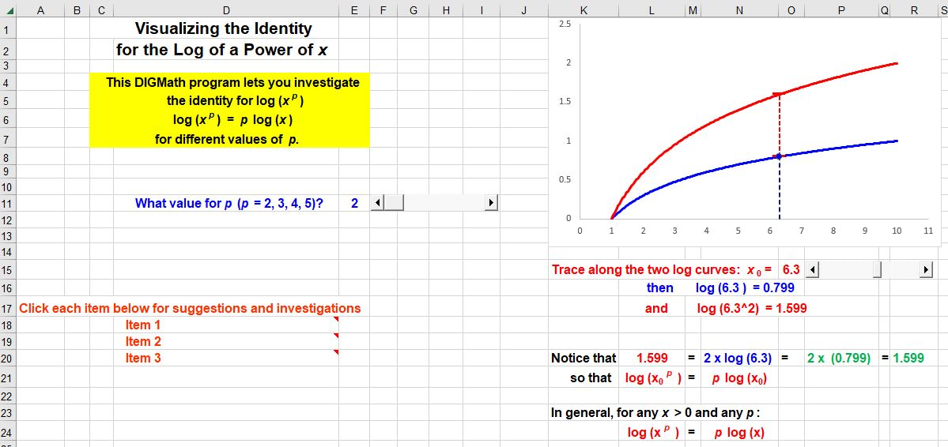
Figure 1: The Log of x² Identity

In a similar way, with the choice of p = 3, the corresponding output is shown in Figure 2. The main difference here is that the upper portion of the vertical line, for any tracing point x₀, is twice the length of the lower portion, as can be seen from the tick-marks corresponding to the multiples of log (x₀). Thus, students can see visually that log x³ = 3 log x. The associated numerical values are also displayed in the corresponding colors to reinforce the connections.
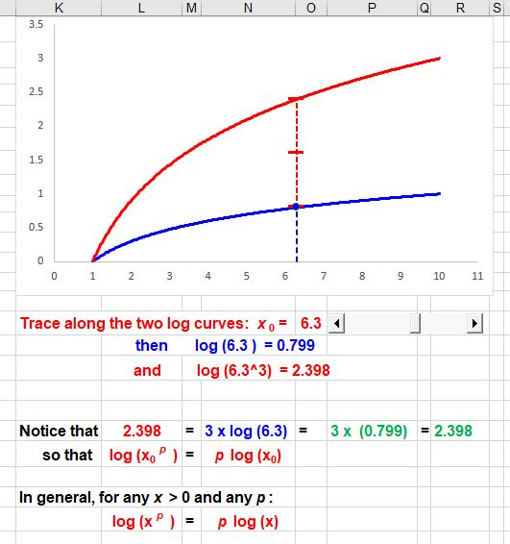
Figure 2: The Log of x³ Identity
The spreadsheet also allows the user to see the corresponding results with p = 4 (the height of the upper portion of the vertical tracing line is now four times that of the lower portion of the line) and with p = 5 (where the height of the upper portion is now five times that of the lower portion). Together, these displays present very convincing evidence that the relationship is true for all values of p and for all values of x – that is, log (x^{p}) = p log (x) is truly an identity. That is much more effective for most students than a purely algebraic approach that may be intellectually convincing, but is too often not really understood and hence is not planted very solid in many students’ minds. However, when many students have a solid image of what such a formula means, they are more likely to retain the memory of the identity or be able to reconstruct it from the visual image.

The Logarithm of a Product Identity
We next consider the product identity for logarithms: log (a*b) = log (a) + log (b). The dynamic spreadsheet associated with it, as shown in Figure 3, lets the user input the values for a and b using a pair of sliders. It displays the associated values and calculations in varying colors to help students keep track of which items refer to each element, and draws the graph of the logarithmic function. It also displays the values for a, b, and ab on the chart and the associated heights for each (in blue, red, and green, respectively) as well as the location of the product a*b and its associated height. Finally, it presents the details on the use of the calculated values to show how the sum of the logarithms of a and b work out to be the logarithm of the product. As the user alters the values of a and b with the sliders, the elements in the chart change smoothly and provide a dynamic view of how the various values change and so help make the recognition clearer in students’ minds that the end result involving the product of a and b is easier to comprehend.

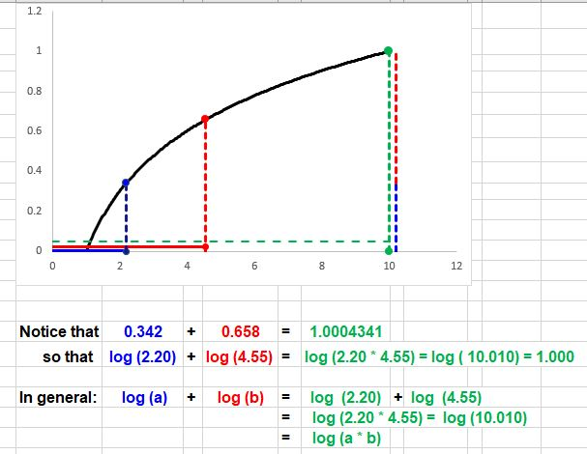
Figure 3: The Product Identity for Logarithms
The Rule for the Logarithm of a Quotient
We next consider the quotient identity for logarithmic functions, or equivalently the rule for the logarithm of a quotient: log (a/b) = log (a) - log (b).
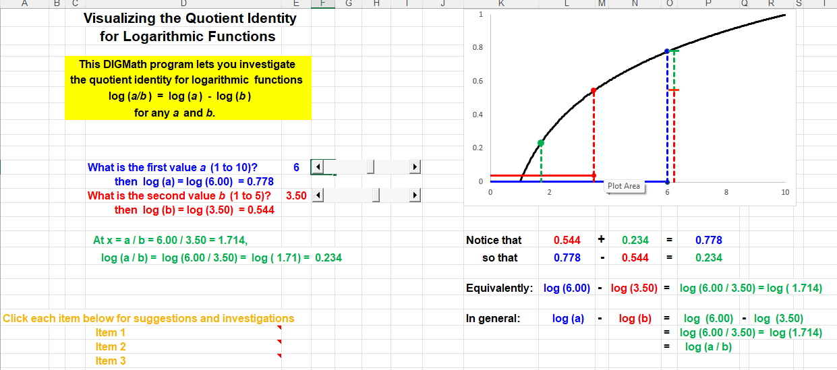
Figure 4: The Quotient Identity for Logarithms
The associated spreadsheet, as shown in Figure 4, lets the user input the values for a and b using a pair of sliders. It displays the corresponding values and calculations in varying colors to help students keep track of which item refer to each component, and draws the graph of the logarithmic function with base 10. The spreadsheet also displays the values for a, b, and a/b on the chart and the associated heights for each (in blue, red, and green, respectively). Notice that the green vertical line for the quotient is the left-most, because the quotient will be the smallest of the three in numerical value. In order to display the relationship, at the right of the chart, the line beside the blue line for log a is shown composed of two segments, the red line whose height is the value for log b and the green line whose height is equal to log a/b. This display makes it evident to students that, for any particular values that have been inputted for a and any b,
log a = log b + log (a/b).
The identical conclusion is evident for any other values they opt to try. Consequently, it immediately follows that
log a - log b = log (a/b)
for any a and any b.

The Rule for the Product Powers
We now turn to several fundamental identities for exponential functions. We begin with the sum identity for exponential functions (equivalently, the product of powers rule): c^{a + b} = cª c^{b} , for any base c and any a and b. To explore this identity, the authors have developed a spreadsheet that allows the user to enter any desired values for a and b using a pair of sliders. In this particular implementation, the base used is e, though it would be simple to adapt the spreadsheet to work with base 2 or base 10, say; the latter, however, grows much to rapidly to show the details, unless the values for a and b are kept very small, say a maximum of 2 and that could suggest to students that this works only for very small values.
The spreadsheet displays the various calculations associated with these values, using blue output for those entries associated with the first parameter a, red for those associated with b, and green for those associated with a + b. It also draws the graph of the exponential function, includes the values for a and b as a pair of horizontal lines both starting from the origin, displays the associated vertical heights for eª and e^{b}, using the same blue and red color coordination. It also extends the second horizontal line to start at the end of the first blue line to get to x = a + b, and draws the vertical line in green corresponding to e^{a + b}. The spreadsheet also displays the values associated with each step of the identity process so that students can visualize how the third vertical line seems to be associated with the product of the first two heights. The entire display is shown in Figure 5.
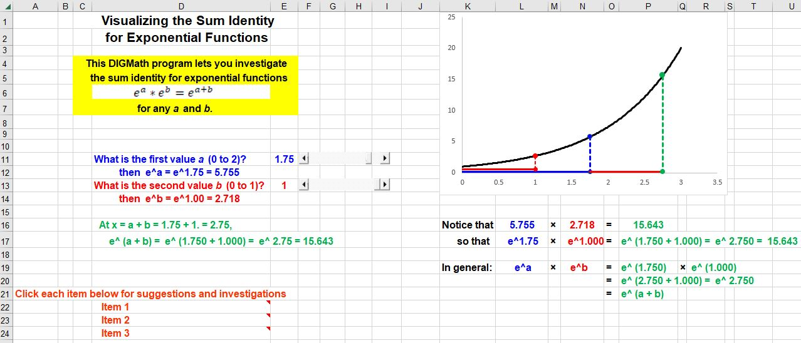
Figure 5: The Sum Identity for Exponential Functions
Moreover, the graphical display and all of the associated calculation steps all change dynamically as the user varies the values for either a or b with the sliders to help convince the students that the same relationship holds for any values of a and b, so that the associated formula is indeed an identity.
The Rule for the Quotient of Powers
Our next case involves the difference identity for exponential functions (equivalently, the rule for the quotient of powers) , e^{a /} e^{b} = e^{a - b} , for any base c and any a and b. For convenience with the display, we use the base e; with larger bases, the exponential function grows too rapidly to make out the visual details clearly. As with the sum identity, the associated spreadsheet allows the user to select the values for a and b and displays the values of eª and e^{b}, in blue and red, respectively. (See Figure 6.) It also draws the graph of the exponential function y = e^{x}, along with vertical lines corresponding to y = eª at x = a and y = e^{b} at x = b in blue and red, respectively. It also draws the vertical line corresponding to the difference a – b in green. Finally, directly to the right of the line at x = a, the spreadsheet also includes a vertical line in green with height equal to e ^{b-a}.
Instead of trying to display the quotient eª / e^{b} in a way that will give students insight into what is happening, the authors have found that it is much more effective to have the spreadsheet take advantage of the fact that it is much easier to picture the product of two numbers. In particular, it points out computationally that with the numbers used to generate this particular image (a = 1.40 and b = 0.50), the height of the blue line at x – 1.40 appears to be roughly 1.50 times as large as e^{a – b} is. More specifically, it demonstrates numerically that the actual multiple is about 1.649, which is the value of e^{b}. Thus, both graphically and numerically, it becomes clear to the students that eª seems to be equal to the product e^{a -b} * e^{b} . Repeating this investigation with other values for a and b provides very convincing evidence that
eª = e^{a - b} e^{b}
for any a and b. Consequently, a simple division leads to the appropriate identity
e^{a - b} = e^{a /} e^{b}
for any a and b.
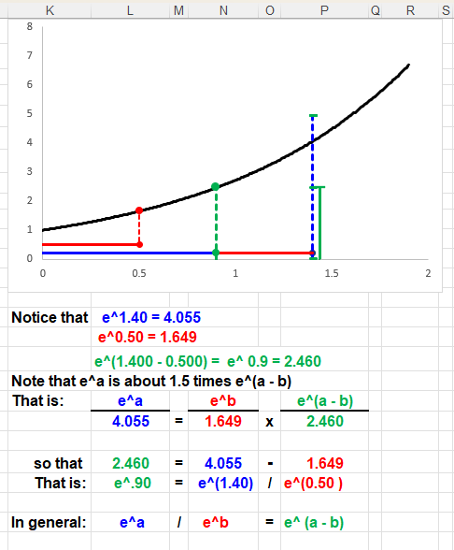
Figure 6: Difference Identity for Exponential Functions

The Exponential and Logarithmic Identities
We finally turn to a consideration of the two fundamental identities relating exponential and logarithmic functions:
log _{b} (b^{x}) = x and b^{log} _{b} ^{x} = x
for any base b. These two rules somehow often appear to be different in some way from the previous rules since they are not quite operational in nature, but more conceptual or theoretical, and consequently often require more emphasis on the underlying concepts.
We begin with the first of these two identities. The display from the associated spreadsheet is shown in Figure 7. Notice that the spreadsheet allows the user to select a value for the base b between b = 2 and b = 8. It also allows the user to select the extent to which the different displays are extended, starting at x = 0.5 (to avoid getting too close to the origin). There are two graphical displays, one the graph of the exponential function y = b^{x} , which is the argument of the logarithmic function, and the other is the graph of the log with base b for that exponential function. Notice that the graph of this expression looks quite linear. The spreadsheet also allows the user to trace along both curves. In addition to the graphical displays, the spreadsheet also shows the associated computational details to illustrate how the final calculations proceed. For example, with the choices shown in the Figure with b = 2.5 for the base and x = 2.85 for the tracing point, it shows that 2.5^2.85 is approximately equal to 13.62. It also shows that the logarithm with base 2.5 of the exponential term, 13.62, is equal to 2.85. That is, log _{2.5} (2.5 ^{2.85}) = 2.85. In fact, the second graph does not merely look “quite linear”; it is precisely linear with a slope of m = 1, because it is actually the line y = x. The formula is an identity that holds for any choice of the base and for any point in the domain for x. This provides both graphical and computational conviction to the students that the result is always equal to the value of x. For those students who are visual thinkers or who depend on numbers, this investigation provides results that make sense and so are more likely to stick with the students.
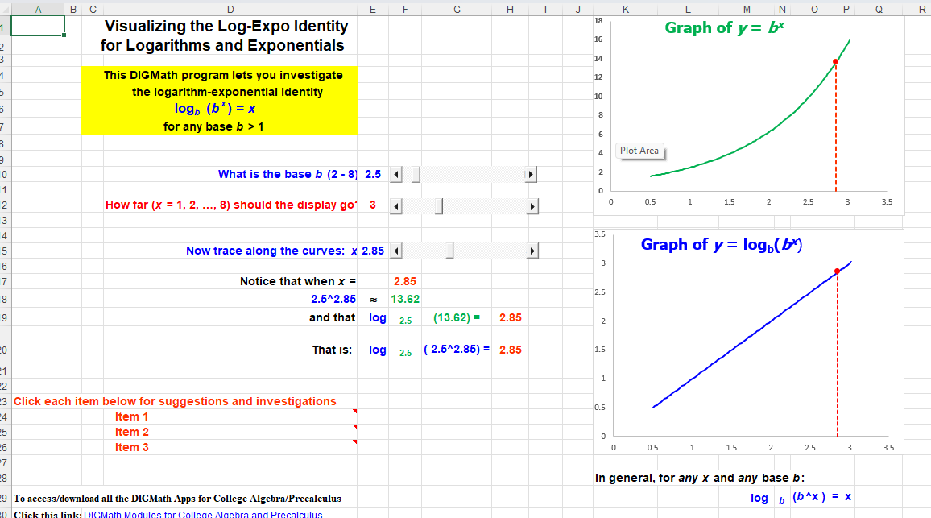
Figure 7: The Identity log (b^{x}) = x.

We now turn to the second of these two identities, b^{log} _{b} ^{x} = x . The display from the associated corresponding spreadsheet is in Figure 8. As with the preceding case, the spreadsheet allows the user to select a value for the base b between b = 2 and b = 8 and to select the extent to which the different displays are extended, starting at x = 0.5. Again, there are two graphical displays, one the graph of the logarithmic function y = log _{b} x and the other is the graph of the exponential function with base b raised to that logarithmic power. Again, it is apparent that the second graph also looks quite linear. The spreadsheet also allows the user to trace along both curves. In addition to the graphical displays, the spreadsheet also shows the associated computational details to illustrate how the final calculations proceed. For example, with the choices shown in the Figure with base b = 5 and x = 2.20 for the tracing point, the spreadsheet shows that log _{5.0} (2.20) = 0.49 and that 5.0 ^{log} _{5.0} ^{(2.20)} = 2.20. It also shows that the logarithm with base 2.5 of the exponential term, 13.62, is equal to 2.85. That is, log _{2.5} (2.5 ^{2.85}) = 2.85. Furthermore, the second graph in the Figure is precisely the line y = x, for any x. Again, this provides students with both the graphical and computational conviction that the result is always equal to the value of x
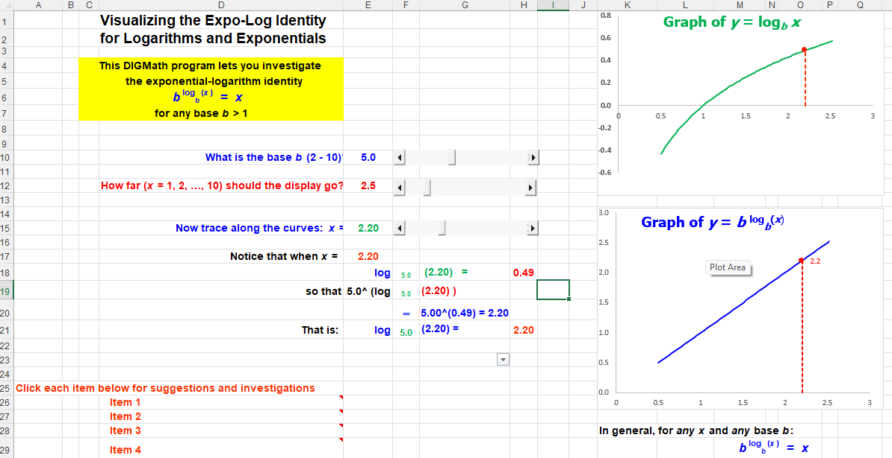
Figure 8: The Identity b^{log} _{b} ^{x} = x.

Final Remarks
Comparable modules to the ones described here can certainly be developed with other specialized software platforms such as GeoAlgebra or Geometer’s Sketchpad or possibly even for TI and other graphing calculators. However, we believe there are some fairly strong reasons to use Excel. First, Excel is almost universally available versus specialized mathematics packages. Certainly, if students were to use dynamic software in a library or other setting outside of the actual mathematics classroom, Excel would almost certainly be available, but not any specialized software. Second, unless students come into a particular math class from a preceding course that also used such specialized software, they will be totally unfamiliar with the software platform and it would take lots of time to get them to become familiar and comfortable with using it. On the other hand, it is the author’s perception that most student are exposed to Excel as early as even intermediate school, though not necessarily in math classes, so they are already familiar and comfortable using spreadsheets, even if only at the most rudimentary level. However, that is all that is required to use the author’s dynamic software – the lowest level of familiarity with Excel.
As far as graphing calculators are concerned, while excellent programs are available to demonstrate mathematical concepts and methods graphically and somewhat dynamically, there is always the limitation on the level of resolution on the very small screen. Moreover, there are definite speed limitations with using such calculators that make using them dynamically somewhat of a challenge, to put it mildly.
Finally, in terms of implementation of the ideas here, we feel that it likely would not be advisable to try to utilize all seven of the Excel spreadsheets in a classroom setting; it could too easily overwhelm and confuse the students. Rather, we would recommend choosing perhaps only two or three of the modules in any given semester to provide the dynamic, the visual, and the numerical support that many students would benefit from in terms of giving them more insight into the rules than they would get solely from algebraic derivations. However, those few exposures would almost certainly serve to convince the students that comparable demonstrations could be presented to showcase the other rules they have to learn and use.

Reference
Author, (2023), Looking for Trig Identities, (submitted)
Authors, (2023), The Logarithm of a Power Rule, dynamic spreadsheet, URL to be supplied.
Authors, (2023), The Logarithm of a Product Rule, dynamic spreadsheet, URL to be supplied.
Authors, (2023), The Logarithm of a Quotient Rule, dynamic spreadsheet, URL to be supplied.
Authors, (2023), The Product of Powers Rule, dynamic spreadsheet, URL to be supplied.
Authors, (2023), The Quotient of Powers Rule, dynamic spreadsheet, URL to be supplied.
Authors, (2023), The Logarithm of a Power Identity, dynamic spreadsheet, URL to be supplied.
Authors, (2023), The Power of a Logarithm Identity, dynamic spreadsheet, URL to be supplied.

