Buffonery In the Math Classroom

One of the most famous examples in introductory probability is Buffon’s Needle Problem in which a needle of a given length L is dropped onto a floor composed of a series of long planks of a given width W and the question raised is to determine the probability that the needle lands entirely within one of the planks. Equivalently, one can ask what is the probability that the needle lands so that it crossed the boundary between adjacent planks?
The problem is somewhat challenging in the sense that an exact answer involves the definite integral of a sine function, so it is not accessible to other than classes where the students have had several semesters of calculus. Often, the problem is also used as a lovely demonstration of how various random simulation techniques can be used to generate reasonably accurate answers to relatively complicated probability problems. For instance, one could perform a physical simulation with, say, 100 identical needles by dropping them onto a wooden floor and counting the number of needles that end up crossing the boundary between planks. Or, the simulation could be conducted by dropping 100 wooden pencils, ice cream sticks, or pick-up sticks from the child’s game. Unfortunately, there are several potential pitfalls – you need a rather large open area to conduct the simulation; it can be a rather chaotic classroom activity; the needles or whatever used can roll under furniture or radiators; and it will take a lot of class-time to compile the results, particularly if you want to conduct the experiment repeatedly to convince students that the results are reasonably consistent from one toss of the “needles” to the next.
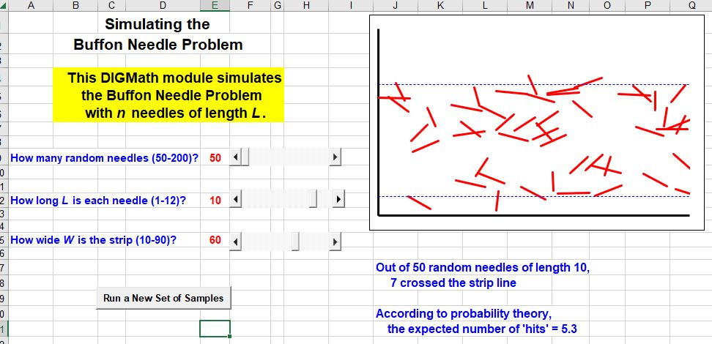
The authors have found that all of these drawbacks can be very easily overcome by using dynamic graphical simulations on the computer to provide much deeper understanding to the students not only of the Buffon problem, but also many other problems in techniques across the entire undergraduate curriculum. In the version developed by the authors to simulate the Buffon problem, the user can select the length L of the “needles”, the number n of them, and the uniform width W of the planks using “sliders”, which are one of the built-in controls in Excel. The program randomly generates the landing positions of each of the n needles, and displays the needles graphically, so that students can see and themselves count the number of needles that end up crossing the boundaries of the plank. An input button (another one of the Excel controls) provides a simple way to generate a new random sample, and the students can see the resulting outcomes both graphically and numerically virtually instantaneously. Figure 1 shows the graphical image for one run of this program using n = 50 needles of length L = 10 landing with at least one end inside a plank whose width is W = 60. It is fairly clear from the image that 7 of the 50 needles crossed the boundary, though several others appear to be very near misses. The program also reports on the actual number of crossings, as well as the expected number based on probability theory.
Figure 1: Buffon Needle Simulation

If most of the students have not seen such dynamic simulations previously, the authors believe that it is important to spend a few minutes making sure that the students understand what they are seeing so they can make sense of the results. This might involve selecting a small number of needles (say n = 50, the smallest number available on this implementation) with a relatively large length and look at perhaps three different runs to point out how there are dramatically different random needles generated, but that the number, or the percentage, that land across the top and bottom boundary strips is fairly consistent from one set of samples to the next. We would then decrease the length to demonstrate that fewer of the needles land across the boundary until with very small lengths, very few of the needles cross the boundary strips. At this point, it makes sense to increase the sample size, say first to 100 and then to 200, to indicate how the larger sample sizes result in more consistent results that better match the predicted theoretical percentages or counts. With the speed of the simulation, this entire process likely takes about 10 minutes of class-time and provides a tremendous gain in student understanding and consequently a willingness to accept the results of repeated random simulations as being reasonable.
In this article, we consider a variety of comparable, though usually much simpler, problems that are similar to the Buffon needle problem, but which are far more accessible mathematically to virtually every student in an introductory statistics or probability course.

The Buffon Needle Problem
Before considering alternative problems, we briefly outline how one obtains the actual solution to the standard Buffon problem. Consider a single needle of length L landing on a long floor plank, as shown in Figure 2. That needle will lie entirely inside a plank if one end (say the end with the eye) is sufficiently far from both the top and the bottom edges of the plank. It will also lie entirely inside the plank if the distance to the nearer edge is smaller, even considerably smaller, provided that the angle of inclination θ is small enough for any θ between 0 and π. In the figure, the vertical distance from the far point of the needle to the horizontal level of the near point is given by y = L sin θ. Therefore, so long as L sin θ < W, the needle will be entirely inside the plank.
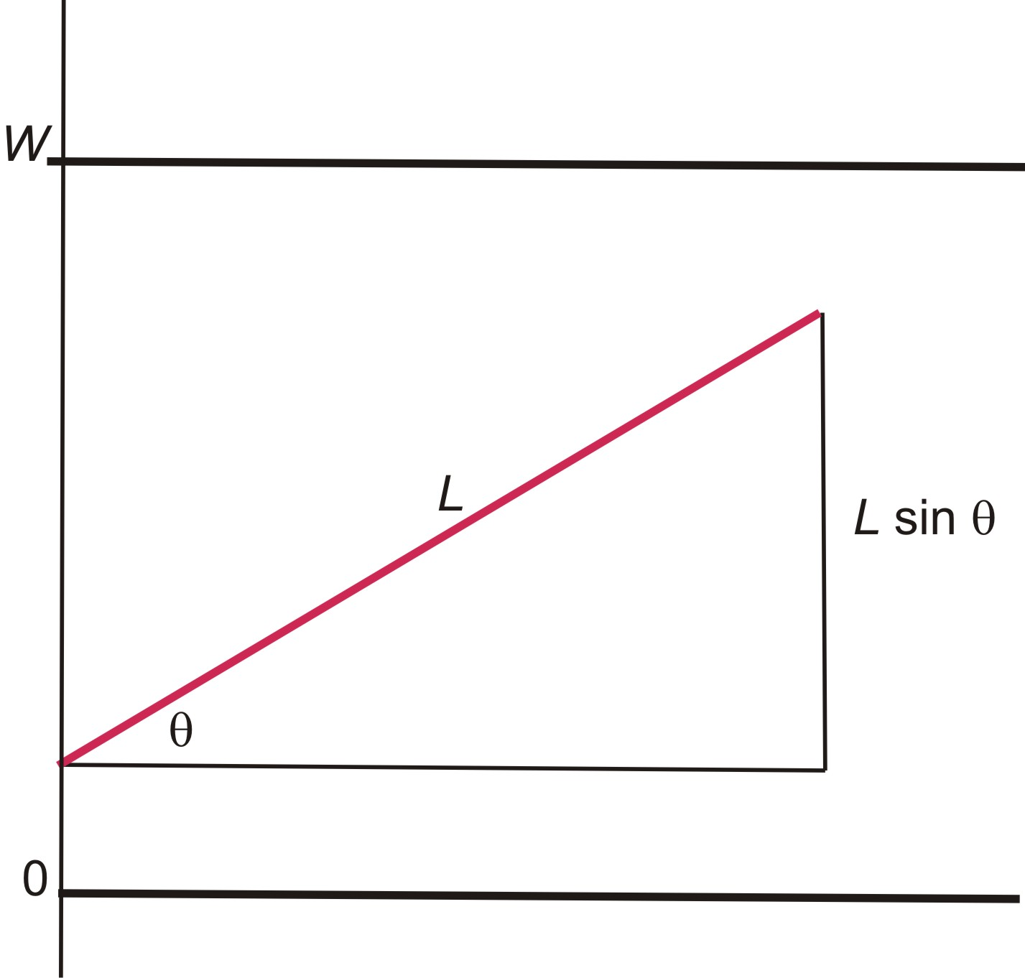
Figure 2: Illustration of Buffon’s Needle

Figure 3: Graph of y = L sin θ on [0, π]

The associated graph of this function of θ is shown in Figure 3. Assuming that the values of y = L sin θ and θ are distributed uniformly, the probability that the needle lies entirely inside a plank is equal to the ratio of the area under the curve y = L sin θ to the total area of the rectangle of width π and height W. That is,
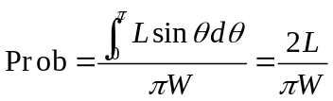.

Buffoon’s Circular Disks on a Long Plank Problem
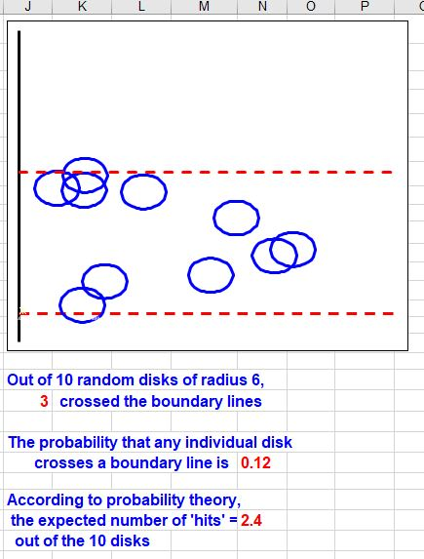
Instead of dropping needles onto a plank, we now drop a set of n circular disks, say a collection of coins, onto a long plank. For this Buffon variation, we again consider a long wooden plank of width W and assume that each of the disks has radius r. Again, the problem involves either finding or estimating the probability that an individual disk either lands entirely within the plank or lands crossing the boundary between adjacent planks. Figure 4 shows the results of one run of the authors’ dynamic spreadsheet based on n = 10 randomly generated disks of radius r = 6 that all land with their centers inside a plank whose width is W = 50. From the Figure, we observe that, in this run of the simulation, 7 of the 10 disks lie totally within the plank and the other 3 cross the boundary. According to probability theory, the probability of any particular disk crossing the boundary is 0.12 and therefore the expected number of disks out of the 10 will be 2.4.
Figure 4: Circular Disks on a Long Plank
The key to finding the associated probability is to randomly generate the center point (x, y) of each disk and then to assess whether or not it crosses the boundary. Suppose that the plank lies horizontally and extends vertically from y = 0 to y = W. The disk lies entirely within the plank if the y-coordinate of the center is somewhere between r and W – r, but the decision does not depend on the x-coordinate. Therefore, as seen in Figure 4, the probability P that the disk lands entirely within the plank is
P = (W – 2r)/W.
Alternatively, the probability Q that the disk lands across the boundary is
Q = 1 - P = 1 - (W – 2r)/W = 2r/W.
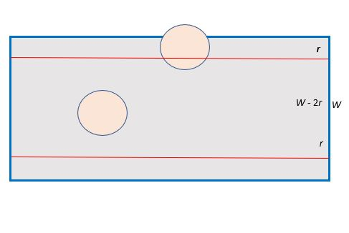
Equivalently, a disk will land across the boundary if the y-value is below r or above W – r, so the associated probability is
Figure 5: Probability of Disk on a Plank
Q = 2r/W.
We note that this is an example of what is known as geometric probability, where the probability of an event is equal to the ratio of the areas of two plane regions and can often be solved using purely geometric considerations without the use of calculus. Other geometric probability examples may involve the ratio of the lengths of two line segments or the ratios of the volumes of two solids in space.
Clearly, this disk experiment could be simulated physically using a collection of coins, but that tends to lead to chaos in the classroom with coins rolling in all directions and furniture getting in the way (but with happy cleaning staff at the end of the day). Worse, doing this in class is incredibly time-consuming and rather hard for all the students to see, particularly in a relatively large class. The simulation avoids all these complications, so the presentation can focus on mathematical and probabilistic ideas.
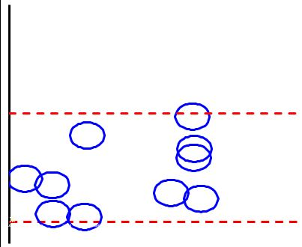
Perhaps the most important statistical ideas that students need to see and understand is the concept of randomness within a sample and randomness between different samples. These ideas come to life when a dynamic simulation is run repeatedly. For instance, if we repeat the simulation with the same values as used to generate Figure 5, we get the results shown in Figure 6. Clearly, the pattern of how the 10 disks are positioned has changed dramatically, so there is substantial variation between the two different samples. However, in this run, we again observe that only 3 of the 10 disks landed across the boundary of the plank, so there is considerably more consistency in the number of outcomes, either successes or failures. In fact, if the simulation is run repeatedly, the number of crossings will vary somewhat, but will almost always turn out to be fairly close to the theoretical prediction of 2.4. Moreover, this point becomes even more evident if a larger sample, say n = 50 or n = 100, is used.
Figure 6: Another run of the simulation
It is also useful to the students to see what happens as, say, the radius of the disks increases, perhaps from r = 5 to r = 6 or even to r = 9 or 10; it is also valuable to explore what happens as the radius decreases, say to r = 3 or even r = 1. In particular, it is a good mental exercise to ask the students to anticipate what they will see as r increases or decreases. In a similar vein, it would be an effective exercise to ask what they would expect to see if the width W of the plank increases or decreases, both graphically and numerically.

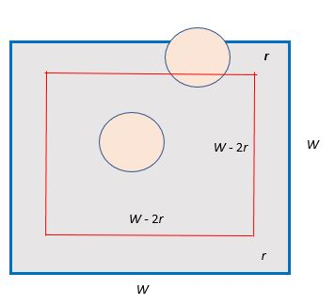
Buffoon’s Circular Disks in a Square Tile Problem
Figure 7: Probability of a Disk in a Square Tile
We next consider a different variation on the Buffon Disk Problem in which, instead of having a floor composed of long planks, the floor is composed of square tiles whose dimensions are W by W. Figure 7 shows one such tile and the smaller square inside it that extends both horizontally and vertically from r to W – r consists of all points at which a disk is centered that lies entirely within the square. The region outside the smaller interior square consists of all points where a disk is centered that crosses the boundary of the tile. The area of the entire tile is simply A = W² and the area of the inner square is A = (W – 2r)². The associated probability P that a disk lands entirely inside the tile is
P = (W – 2r)²/W ².
Consequently, the probability that a disk crosses any of the four sides of the tile is
Q = 1 - (W – 2r)²/W ².
We have developed another dynamic simulation for this situation in which the user can select the number n of random disks, the radius r of the disk, and the width W of the tile. The program generates n random disks whose centers all lie inside the tile and it then displays the tile, the set of random disks, and the number and percentage of those disks that lie entirely inside the tile. It also displays the expected number of such disks for comparison. One set of outcomes using n = 10, r = 3, and W = 25 is shown in Figure 8, where 3 of the disks cross an edge of the tile; a second set with the same parameter values is shown in Figure 9, where 4 of the disks cross an edge. Based on the formula above for the probability, the chance of a single disk crossing an edge is 0.42, so with n = 10 disks, we would expect that 4.2 would cross. As with the previous cases, the different runs produce dramatically different distributions for the disks (meaning there is great variation within each sample) although the numbers of successes tend to be much more consistent (little variation between samples).
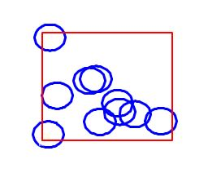
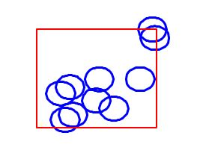
Figure 9: Another run of 10 disks of radius 3
Figure 8: 10 disks of radius 3

It is helpful for the students to consider first what they expect will happen if, say, the radius is larger or smaller and then what “actually” happens in the random simulations. Similarly, they should be asked to anticipate what will likely happen as the width of the tile increases or decreases.

Buffoon’s Needle on a Square Tile Problem
We now consider a seemingly simple variation on the standard Buffon needle problem where the needles land on a floor made up of square tiles instead of long planks. We note that Buffon tried to solve what seems to be a slight variation on this problem where the floor is made up of rectangular tiles of size a by b and the length of each needle is L. However, Buffon’s solution was incorrect and, some 50 years later, Laplace came up with a correct solution. It turns out that the probability P of a needle crossing any boundary is
$P=\frac{2L}{πa}+\frac{2L}{πb}-\frac{L2}{πab}$P = 2L/aπ + 2L/bπ - L²/abπ = [2(a+b)L – L²]/abπ.
In the present case with square tiles of dimension W by W, Laplace’s result reduces to
P = 4L/wπ - L²/W²π = [4WL – L²]/W²π
and consequently the probability that a needle does not cross any boundary is
1 - P = 1 - [4WL – L²]/W²π.
See Arnow [1] for details.
The authors’ simulation [5] of this situation with square tiles allows the user to select the number n of needles, the length L of the needles, and the width W of the tile and produces images such as the one in Figure 10. In this case, based on n = 50 needles of length L = 7 and tiles of width W =50, we have 9 needles that cross an edge. The theory predicts that the probability of a single needle crossing an edge is 0.48, so that one would expect that 8.6 of the 50 needles would cross one of the edges of the tile. Repeated trials reinforce these conclusions, although the pattern in the needles generated is quite different on each run.

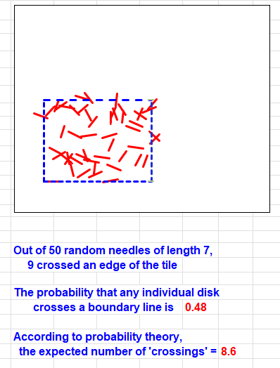
Figure 10: 50 needles of length 7 on square tile
Buffon’s Square Coins on a Square Tile Problem
Our next variation on the Buffon needle problem is the case where one repeatedly drops small square disks (say, the square coins used in India, Pakistan, the Bahamas, Aruba, and some other nations) where one corner lands inside a square tile. Such a coin crosses the boundary of the tile if its opposite corner either lands outside of the tile or right on any of the four border edges of the tile, as shown in Figure 11. Mathematically, this is a somewhat more complicated situation for an introductory statistics or probability class.
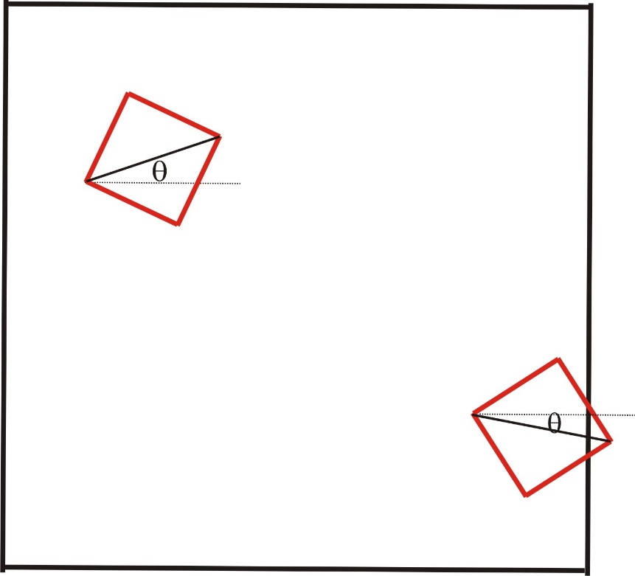
Figure 11: Square Coins on a Square Tile

The simplest way to generate the landing position of such a coin is to randomly select a point (x₀, y₀) inside the square tile as a starting point (one corner) for the coin and then generate a random angle θ to locate the opposite corner of the coin at (x_{f}, y_{f}). Depending on the values of x_{f}, and y_{f} , one can easily decide if the coin lies entirely inside the tile or if it extends beyond it in any direction: that is, if x_{f} < 0 or x_{f} > W or if y_{f} < 0 or y_{f} > W, the square coin lies entirely within the tile.
From a computational point of view, one can think of the diagonal distance from the starting point (x₀, y₀) to the ending point (x_{f}, y_{f}) of a square coin as being mathematically equivalent to the length of a needle extending from (x₀, y₀) to (x_{f}, y_{f}), where the length is simply equal to the hypotenuse D. Thus, the probability of such a coin landing completely inside a square tile or crossing the boundary of the tile is equivalent to the calculations for a needle, other than that the value of D is used instead of the length L of the needle.
The results of a simulation using 25 such coins of width 5 with a tile whose sides are 30 are shown in Figure 12. Without repeating the details, the same kinds of questions and investigations we suggested in previous examples can be raised for this situation to improve student understanding of the concepts through the dynamic experimentations.
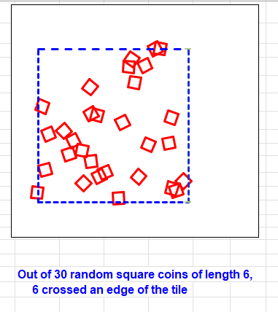
Figure 12: Simulation of Square Coins on a Square Tile

Clearly, this problem could be extended to the cases of square coins and long planks or square coins and a large circle, though we have not done either yet.

Buffon’s Circular Disks on a Circle Problem
We next consider the problem of estimating the probabilities involved in dropping a collection of circular disks of radius r onto a floor in the shape of a large circle of radius R. The authors’ dynamic simulation [7] allows the user to choose the number n of disks, the radius r of each disk, and the radius R of the circle on the floor. The results of one run of the simulation, with 20 disks of radius 5 dropped into a circle of radius 25 are shown in Figure 13. Note that 5 of these disks cross the circular boundary, while probability theory predicts that 4.0 are expected, on average. As mentioned previously, repeated runs of the simulation with the same parameter values produces very similar values for the number of disks that land entirely within the large circle, though the patterns in positions of those disks varies greatly from one run to the next.
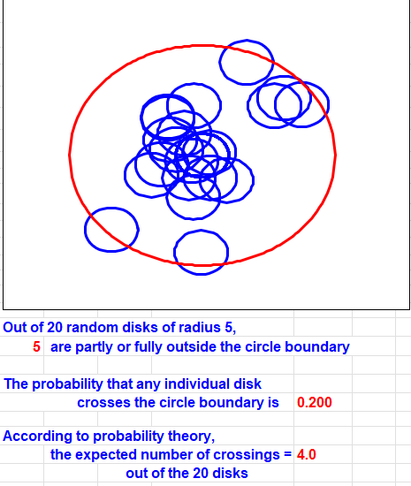

Figure 13: Simulation of Disks on a Large Circle

Buffon’s Needles in Concentric Circles Problem
Our final variation on the Buffon Needle Problem involves dropping needles onto a floor made up with concentric circles, as in a dartboard. We assume that the difference in the successive radii are constant. The associated dynamic spreadsheet [8] allows the user to select the length of the needles, the number of needles, and the fixed distance between the successive circles. The results of one such run with 50 needles of length 5 where the distance is 10 are shown in Figure 14.

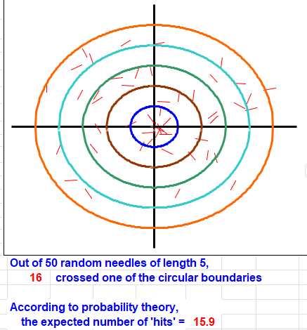
Figure 14: Simulation of Needles in Concentric Circles

We note that this could be extended to consider the case where, instead of needles, circular disks are dropped onto the concentric circles or, for that matter, square coins are used. However, we have not tried to implement either of these situations. We invite interested readers to experiment with these and undoubtedly many other possibilities.

Historical Note
The idea for Buffon’s Needle Problem was first raised by Georges Louis Leclerc [9], better known as the Comte de Buffon, in his paper, Sur le jeu de franc-carreau, published in 1733. However, Buffon had previously examined the associated problems of coins landing within the boundaries of long planks and coins landing on the boundaries of square tiles. Unfortunately, over the years, the latter examples have been essentially ignored, probably because the mathematics behind most of them is much simpler, and consequently only the needle problem has found its way into most textbooks. Unfortunately, from a pedagogical standpoint, this is precisely backward since the easier problems are far more accessible to a much wider audience of students, especially in introductory statistics and probability courses.
In particular, most of the students who take introductory statistics courses are non-math/science majors; they are students in business and finance, psychology, and so forth. If such students take any calculus at all, it will be an applied calculus course rather than mainstream calculus, and likely will not see any mention of the calculus of the trigonometric functions. As a result, they will not have the background needed to appreciate a discussion of the classical Buffon needle problem.

References

- Arnow, Barry J., On Laplace’s Extension of the Buffon Needle Problem, College Math J., 25, pp 40-43, 1994.
- Authors, Buffon’s Needle Problem, dynamic Excel spreadsheet, URL to be supplied.
- Authors, Buffon’s Disks on A Long Plank Problem, dynamic Excel spreadsheet, URL to be supplied.
- Authors, Buffon’s Disks on Square Tile Problem, dynamic Excel spreadsheet, URL to be supplied.
- Authors, Buffon’s Needles on Square Tiles Problem, dynamic Excel spreadsheet, URL to be supplied.
- Authors, Buffon’s Square Coin in Square Tile Problem, dynamic Excel spreadsheet, URL to be supplied.
- Authors, Buffon’s Disk in A Circle Problem, dynamic Excel spreadsheet, URL to be supplied.
- Authors, Buffon’s Needles in Concentric Circles Problem, dynamic Excel spreadsheet, URL to be supplied.
- Leclerc, Georges Louis (Comte de Buffon), Sur le jeu de franc-carreau, Contribution to the Royal Academy of Sciences. From the reports of the Academy, 1733, pp 43-45.

