Variations On a Theme of Fibonacci

Ever since Fibonacci introduced what is known as the Fibonacci sequence to Europe in the early years of the thirteenth century as a mathematical model to describe the growth of the rabbit population, the sequence has been an incredibly rich source of inspiration to mathematicians, students, and the general public. The sequence consists of the numbers {1, 1, 2, 3, 5, 8, 13, 21, …} and has the property that each entry is equal to the sum of the preceding two terms. Surprisingly, a large number of natural processes fall into this pattern, including the number of petals in flowers or the number of chambers in each ring of certain seashells. See, for example, [4].
In addition, it turns out that the ratio of successive terms in the sequence, such as 3/2, 5/3, 8/5, …, very quickly converge to a quantity known as the Golden Ratio, φ ≈ 1.61798. This too has many unexpected applications in nature and in the human perception of the world around us. For instance, DaVinci studied how all manner of proportions of the human body fall into ratios very close to the Golden Ratio [1] and, going further back in time, the Parthenon in Athens was apparently designed so that the ratios of its various dimensions reflect this number.
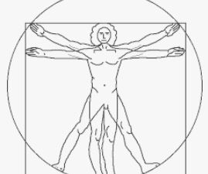

Figure 1: DaVinci’s Sketch of the Proportions of the Human Body

Many people have studied variations on the Fibonacci sequence. Perhaps the most famous is the Lucas sequence, introduced by the French mathematician Lucas in the late 1800’s. It uses the same pattern as the Fibonacci sequence where each entry is the sum of the preceding two, but uses any possible pair of starting values. For instance, if the two initial values are L₀ = 2 and L₁ =1, then the corresponding Lucas sequence consists of {2, 1, 3, 4, 7, 11, 18, 29, 47, 76, …}. There are many interrelationships between the Fibonacci and Lucas sequences, though probably the most interesting is the fact that the ratio of successive terms also converges to the Golden Ratio. Using the same starting values 2 and 1, the successive ratios are ½, 3, 43, 7/4, …, 76/47 ≈ 1.61702, which already agrees with the Golden Ratio to three decimal places. As demonstrated in the Appendix, the ratio of the successive ratios in the Lucas sequence always converges to the Golden Ratio for any two starting values other than L₀ = L₁ = 0.
To assist students in visualizing and hence better understanding what is happening, one of the authors has developed a collection of dynamic investigations in Excel that are available, gratis, to any interested reader for use in classroom presentations or to share with students for their own explorations of the subject. One of these is a spreadsheet designed to explore Lucas sequences that displays, among other things, the following charts in Figures 2a, 2b, and 12c based on the starting values 2 and 1. The three vertical lines in Figure 2a are color-coordinated to demonstrate visually that each term is the sum of the previous two entries. Figure 2b illustrates that the successive ratios converge rapidly to a limiting value roughly equal to 1.6, which is close to the Golden Ratio. The display also suggests that the successive ratios converge in an oscillating manner. This latter idea is emphasized in Figure 2c by showing the differences between the ratios L_{n+1}/L_{n} and φ by expanding the size of the oscillations.

Figure 2a: The successive terms of the sequence showing how each term is the sum of the previous two

Figure 2b: The successive ratios showing how they converge

Figure 2c: The differences between the successive ratios and φ showing how they converge in an oscillatory manner

In this article, we look at a number of variations on the Fibonacci sequence that extend it in different ways. We suggest that readers who are not familiar with the details on finding the solutions of second order linear difference equations with constant coefficients look at the Appendix before proceeding with the main article.

Sums of Three Successive Terms
We begin with a variation on the Fibonacci sequence that is based on the rule that each successive entry is the sum of the three preceding terms. It is based on specifying the first three initial values, T₀ , T₁, and T₂ and all subsequent terms are determined by the difference equation
T_{n+3} = T_{n+2} + T_{n+1} + T_{n} or equivalently T_{n+3} - T_{n+2} - T_{n+1} - T_{n} = 0.
For instance, if T₀ = T₁ = T₂ =1, then T₃ = 1 + 1+ 1 = 3, T₄ = 1 + 1 + 3 = 4, and so forth.
This sequence was originally studied by Agronomof [1] with all three initial values equal to 1, but applies to any other set of starting values for T₀, T₁, and T₂. The sequence was subsequently named the Tribonacci sequence by [3].
A display of the successive terms of the sequence starting from T₀ = T₁ = T₂ =1 is shown in Figure 3a and the ratios of the successive terms are shown in Figure 3b.

Figure 3a: The successive terms of the sequence showing how each term is the sum of the previous three

Figure 3b: The successive ratios for the Tribonacci Sequence showing how they converge

Figure 3a clearly shows how rapidly the terms in the Tribonacci sequence increase. Moreover, the four vertical lines, which are color-coordinated, reinforce the fact that each term is the sum of the previous three terms.
Notice from Figure 3b that the successive ratios clearly converge to a value approximately equal to 1.8. The computational component of the spreadsheet shows that the limit of the ratios is actually close to 1.839287, which is relatively close to φ ≈ 1.61798, though obviously it is not the same limit. In fact, it makes sense that the ratios converge to a number larger than φ since each term is the sum of three previous terms and therefore the Tribonacci sequence grows faster than the Fibonacci or Lucas sequence.
To get a more detailed analysis of what happens with the Tribonacci sequence, we need to extend the concepts in the Appendix. The defining relationship, T_{n+3} - T_{n+2} - T_{n+1} - T_{n} = 0, is a third order linear homogeneous difference equation with constant coefficients. The associated characteristic equation is the cubic
r³ - r² - r - 1 = 0.
There is no obvious way to factor this expression, nor is the rational root theorem of any use since neither r = 1 nor r = -1 is a root. If we look at the graph of the function, as shown in Figure 4, we see that there is only one real root and consequently a pair of complex conjugate roots. Using numerical or graphical techniques, we find that the real root is r ≈ 1.83928675. Also, we note that the successive ratios appear to converge to this limit in an oscillatory manner, as is the case with the Fibonacci and Lucas sequences.

Figure 4: The graph of the characteristic equation associated with the Tribonacci Equation

Actually, there is a formula for solving for the roots, real or complex, of any cubic polynomial and it produces the following exact solution for the real root of the cubic:

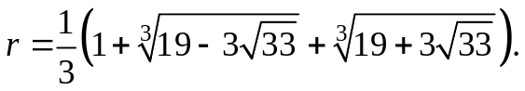
The complexity of this expression certainly suggests that if one extends this variation on the Fibonacci sequence still further to a sequence where each term is the sum of the four previous terms (dubbed the Tetrabonacci sequence by Feinberg (1963)) or higher, the likelihood of generating closed form solutions for the limits of the successive ratios is rather remote beyond the fourth degree. Incidentally, the limit of the ratios of the successive terms in the Tetrabonacci sequence is roughly 1.92756, which is slightly larger than that, 1.83929, for the Tribonacci sequence. In Figure 5, we show the graph of the associated quartic characteristic polynomial r⁴ - r³- r² - r - 1 = 0 and observe that it seemingly has 2 real roots and a pair of complex roots. In particular, the real root toward the right occurs at roughly r ≈ 1.927, which is essentially the same as the ratio of the successive terms. In general, the largest real root in absolute always occurs at the limiting ratio.

Figure 5: The graph of the characteristic equation associated with the Tetrabonacci Equation

Differences Instead of Sums
We next consider another variation on the Fibonacci and Lucas sequences based on the rule that each successive entry is the difference, rather than the sum, of the preceding two terms, so that the generating relationship is
G_{n+2} = G_{n+1} - G_{n} or G_{n+2} - G_{n+1} + G_{n} = 0.
For instance, suppose we start such a sequence with G₀ = G₁ = 1. Then the terms of the sequence are {1, 1, 0, -1, -1, 0, 1, 1, 0, -1, …} and so on through the same cycle of six digits. Alternatively, if we start with G₀ = 1 and G₁ = 2, then the resulting sequence consists of {1, 2, 1, -1, -2, -1, 1, 2, } and we again have a cycle of six digits repeating over and over. Similarly, if G₀ = 1 and G₁ = 3, then the resulting sequence is {1, 3, 2, -1, -3, -2, 1, 3, … } and we again have a cycle of six digits repeated indefinitely. Finally, if we start with G₀ = 1 and G₁ = 4, then we obtain {1, 4, 3, -1, -4, -3, 1, 4, …} and once again we have a cycle of length six. We show the results based on G₀ = 1 and G₁ = 3 in Figure 6, where the periodic pattern is quite pronounced.
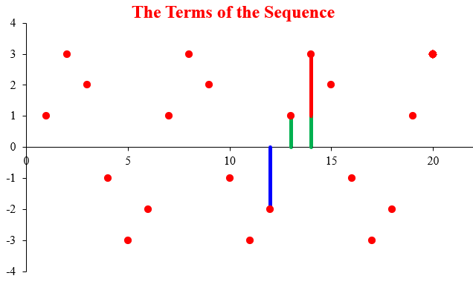
Figure 6: The successive terms of the sequence showing how each term is the difference of the previous two

To understand what is happening here and why, consider the underlying difference equation G_{n+2} - G_{n+1} + G_{n} = 0, which is a second order linear homogeneous difference equation. The corresponding characteristic equation is
r² – r + 1 = 0,
whose two roots are the complex conjugates
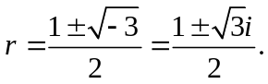
The general solution for any pair of initial conditions therefore takes the form
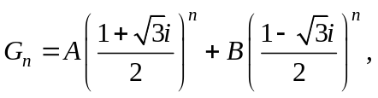
for constants A and B that are determined by the choice of initial conditions. We can expand the powers of the two complex numbers by using DeMoivre’s Theorem. To apply it, we transform any complex number a + bi to the equivalent trigonometric form:
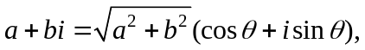
for the appropriate angle θ. For the first term, we have
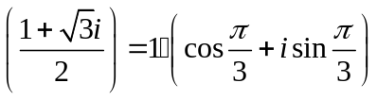
and for the second term,
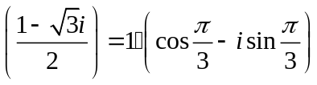.
Therefore, using DeMoivre’s Theorem, the general solution is

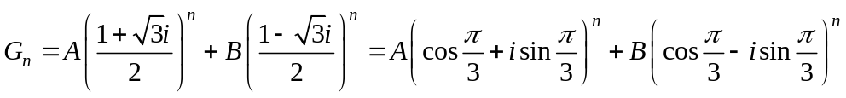

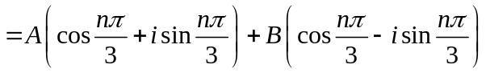

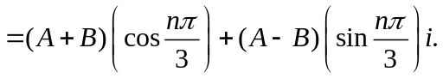
Consequently, we see that the behavior of the solution is clearly periodic. Moreover, because the argument of both the sine and cosine terms is (π/3)n = (2π/6)n, the period of the oscillation is 6. Also, this holds no matter the coefficients A and B, and hence for any choice of initial values G₀ and G₁.
Also, because of the period nature of the solution, there is no point in considering what happens to the ratio of successive terms, since it too will be periodic with period 6.

Products Instead of Sums
Our final variation on the Fibonacci and Lucas sequences concerns the sequence determined by the recursion relation H_{n+2} = H_{n+1}·H_{n}, so that each term is the product of the two preceding terms, given a pair of initial values H₁ and H_{0.} For instance, if H₀ = 1 and H₁ = 2, then H₂ = 1·2 = 2, H₃ = 2·2 = 4, H₄ = 2·4 = 8, H₄ = 4·8 = 32, H₅ = 8·32 = 256, and so forth. Apparently, all terms are powers of 2. Let’s see precisely which powers they are. In particular, H₁ = H₂ = 2 = 2¹, H₃ = 4 = 2², H₄ = 8 = 2³, H₅ = 32 = 2⁵, and H₆ = 256 = 2⁸. Surprisingly, it appears that the powers 1, 1, 2, 3, 5, 8, … , are precisely the terms of the Fibonacci sequence!
Let’s see why this is the case for any value of n. The powers of 2 for the first six terms are certainly the first five entries of the Fibonacci sequence. Since the next term H₇ is the product of two such powers of 2, its power will be just the sum of 5 and 8 to produce 13, the following Fibonacci number, and so forth indefinitely.
In general, suppose that H₀ = a and H₁ = b, where a ≠ b, so that
H₂ = a·b,
H₃ = b·( a·b) = ab²,
H₄ = (ab) · (ab²) = a²b³,
H₅ = ( ab²) · (a²b³) = a³b⁵,
H₆ = ( a²b³) · (a³b⁵) = a⁵b⁸, and so forth.
The powers of the a’s and the b’s are both the successive Fibonacci numbers, but out of phase by 1.
We leave it to the interested reader to investigate what happens if b = a or if b is some power of a, say b = a^{p}. (Note that the choice of H₀ = 1 and H₁ = 1 leads to the rather uninteresting sequence in which H_{n} = 1, for all n.)
Let’s look at what happens with the ratios of these quantities. For any n, in H_{n} the power of a is F_{n-2} (the n-2nd Fibonacci number) and the power of b is F_{n-1} (the n-1st Fibonacci number). Similarly, in H_{n+1} the power of a is F_{n-2} and the power of b is F_{n}. Therefore, their ratio is
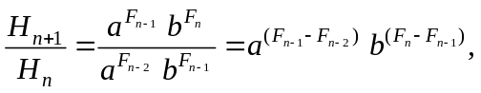
and so the powers of a and b in the ratio are precisely the differences of successive Fibonacci numbers.
Finally, we note that the ideas discussed in the Appendix do not apply in this case because H_{n+2} = H_{n+1} · H_{n} is not a linear difference equation.

Some Additional Variations
Many authors have investigated other variations on the Fibonacci sequence over the years. For instance, the sequence generated by the recurrence relation P_{n+2} = 2P_{n+1} + P_{n} starting with P₀ = 0 and P₁ = 1 consists of {0, 1, 2, 5, 12, 29, …} and is known as the Pell sequence. It has the property that the ratio of the successive terms converges to 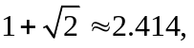which is known as the silver ratio; it is the larger of the two roots of r² – 2r – 1 = 0. The fact that this is larger than the golden ratio indicates that the terms in the Pell sequence increase more rapidly than do those in the Fibonacci sequence, which is evident from the presence of the factor 2 in the defining relationship.
In a similar way, the solution of the difference equation x_{n+2} = 3x_{n+1} + x_{n} , starting with x₀ = 0 and x₁ = 1 consists of {0, 1, 3, 10, 33, 109, …} and the limit of the successive ratios is 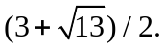 This quantity has been dubbed the bronze ratio. A variety of other so-called metallic ratios have been considered. While we do not go into any of these ideas here, the interested reader may want to see Lamb [4] for a discussion and further interpretations, primarily geometric in nature.
The first author has developed a dynamic spreadsheet, also available from the journal’s website, that allows investigations of the solutions of the generalized relationship P_{n+2} = aP_{n+1} + bP_{n} for any choice of integer multiples a and b between -3 and 4 and starting with any choice of initial values P₀ and P₁ . The associated characteristic equation is r² – ar - b = 0, which has two distinct real roots when the discriminant is positive and a pair of complex roots when it is negative. The spreadsheet uses sliders to select the desired values of the parameters, as well as the number of terms to be displayed. It then draws graphical representations of the terms of the particular solution and the ratio graph of the successive ratios.

Implementation Suggestions
The Fibonacci sequence is introduced to students at many different places in the secondary mathematics curriculum. High Schools First
Likewise, in the collegiate mathematics curriculum, the Fibonacci sequence is also introduced at many different places. It is a standard topic in a Survey of Mathematics course; it is a very basic topic in a low-level Mathematical Modeling course as a way to introduce models of population growth; it is sometimes considered in a modeling-oriented College Algebra or Precalculus course; and it is a very standard topic in an upper division Number Theory course. Needless to say, the presentations can vary dramatically due to the broad range of student backgrounds across all of these courses.
The spreadsheets discussed in this article would be very helpful to many of the students who are introduced to the Fibonacci sequence in the lower level courses, especially Survey of Mathematics, since many of them learn better when ideas are presented graphically. There can be a big jump between talking about a number being the sum of the two previous terms and demonstrating graphically that the number is the sum of the two previous heights. Moreover, for such students, the notation involving subscripts can present a challenge and the visual image helps bridge that gap.
On the other hand, in such a low-level offering, it probably does not make a lot of sense to get into most of the variations we have discussed, though it might be a useful idea to present a couple of examples of Lucas sequences, particularly with the graphical and dynamic support, to reinforce some of the key concepts.
At the other extreme, in a Number Theory course, one can expect that most, if not all, of the students have had an introductory course in differential equations. Thus, they would be familiar with the solutions to second order linear homogeneous differential equations with constant coefficients, as in ay” + by’ + cy = 0 and exposing them to some of the details in the appendix for deriving the closed-form solution to the Fibonacci sequence would provide a solid reminder of the equivalent methods for differential equations. However, the use of the spreadsheets as a graphical display would not be particularly useful for the Fibonacci sequence or the Lucas sequences, though it might provide some good insights into what is happening if an instructor chooses to introduce some of the other variations discussed here. The computational aspect of the spreadsheets might be valuable to provide a quick way to see the successive values of the sequences, to see how rapidly the sequences increase, and to see the convergence of the sequences of successive terms.
Perhaps the best use that could be made of these ideas would be for presentation at a math club, either in a college or a high school. At a high school or for a club in a two-year college type of setting, the basic ideas would be very accessible and interesting and the spreadsheet approach would provide a dynamic dimension that would likely keep the students attention. At a math club at a four-year college or university, presumably the students who attend would likely have a fairly reasonable mathematical background of at least calculus and so could follow some of the more sophisticated ideas in a context that would likely be very interesting to them.
Incidentally, in this context, it would be very appropriate and effective to point out that Mark Feinberg, the author of [3], was a 14-year old junior high school student and that the published article was based on an investigation he conducted for a school math or science project. Perhaps this might inspire other students to think much more positively about mathematics. The authors believe that teachers should suggest comparable investigations with other variations on the Fibonacci sequence to students who might want to participate in math and science fairs. For instance, students could look at a number of variations on the Tribonacci sequence. This might include something relatively simple like varying the initial values to numbers such as {1, 2, 3} or {1, 2, 1} or {1, 3, -1} instead of just {1, 1, 1}. They could examine the behavior of the sequence and the ratio of the successive terms to identify the limiting value.
Or, at a more sophisticated level, some students might be encouraged to investigate the effects of changing the coefficients, so that instead of T_{n+3} =T_{n+2} + T_{n+1} +T_{n} , whose associated characteristic equation is r³ - r² - r - 1 = 0, they might examine what happens with other coefficients, say T_{n+3} = T_{n+2} + 2T_{n+1} - 3T_{n} , whose associated characteristic equation is r³ - r² - 2r +3 = 0. What patterns emerge for the terms of the sequence as the initial values are changed? What is the limit of the ratio of the successive terms? What is the nature of the roots of the characteristic equation and how does the limiting value for the ratios relate to the real roots, if any?

References

1. Agronomof, M. "Sur une Suite Re´currente". Mathesis. 4: 125–126, 1914.

2. DaVinci, Leonardo, The Proportions of the Human Body, (circa 1490).

3. Feinberg, M. "Fibonacci-Tribonacci". Fibonacci Quarterly. 1: 71–74, 1963.

4. Lamb, Evelyn, Meet the Metallic Means, Scientific American, October 21, 2016.

5. Smith, Karl, The Nature of Modern Mathematics, 13th Ed., Cengage Learning, Boston, MA, 2016.

Appendix
The Fibonacci sequence is generated by the recursion relation F_{n+2} = F_{n+1} + F_{n} or equivalently, F_{n+2} - F_{n+1} - F_{n} = 0. This is actually a second order linear homogeneous difference equation:
- The second order refers to the spread of 2 in the subscripts from n to n+2;
- The linear refers to the fact that the only terms involving F are first order terms – there are no products or powers, for instance, of any of the terms;
- The homogeneous refers to the fact that the expression on the right is 0; if it were anything else, it would be a non-linear equation.
More generally, any second order linear homogeneous difference equation can be written
ax_{n+2} + bx_{n+1} + cx_{n} = 0,
where a, b, and c are any three constants. The solution to any such difference equation is made up of two terms of the form x_{n} = Ar^{n}, where A is a constant and r is a value associated with each of the roots of the corresponding characteristic equation
ar²+ br + c = 0.
There are two solutions to this quadratic equation, r₁ and r_{2.} If r₁ and r₂ each are distinct (either both real or both complex), both give rise to an exponential term in the general solution
x_{n} = Ar₁^{n} + Br₂^{n} .
If there is a double real root, r₂ = r_{1,} then the general solution to the difference equation is
x_{n} = Ar₁^{n} + Bnr₂^{n} .
In either event, the two constants A and B are determined by the two initial conditions x₀ and x₁.
For the Fibonacci equation, the characteristic equation is r² - r - 1 = 0, which has two real roots,
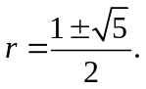
The general solution to the Fibonacci difference equation is then
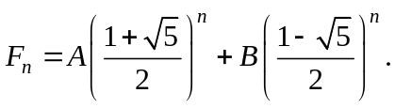
Using the initial conditions F₀ = F₁ = 1, we can determine the values of the constants A and B by solving the resulting pair of simultaneous linear equations corresponding to n = 0 and n = 1. That is,
when n = 0: 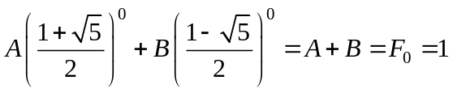
when n = 1: 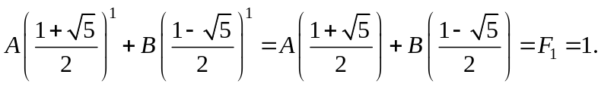

The resulting solution is
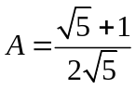 and 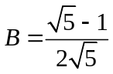.
The expression for the n^{th} Fibonacci number is therefore
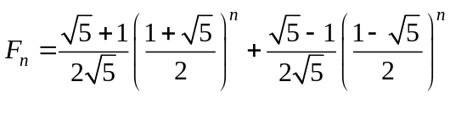
for each n.
Incidentally, the larger of the two roots is known as the Golden Ratio and is denoted by φ = 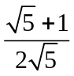 ≈ 1.612… The second root is often denoted by ψ = 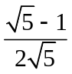 ≈ 0.276… We can therefore write the general solution of the Fibonacci equation, for any n, as
F_{n} = A φ^{n} + B ψ^{n}.
Using this, we can express the ratio of any two successive terms in the Fibonacci sequence as
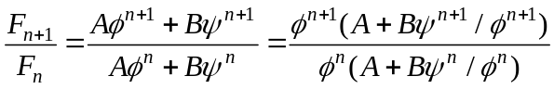

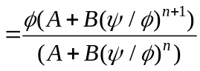 .
However, since φ > ψ, we have ψ/φ < 1 and therefore both (ψ/φ)^{n} and (ψ/φ)^{n+1} approach 0 as n increases and consequently the limit of the ratios is always φ for any initial values F₀ and F₁.
The ideas here on second order linear difference equations with constant coefficients extend in natural ways to third or higher order equations. For instance, as discussed in the body of the article, the third order difference equation associated with the Tribonacci sequence is
T_{n+3} - T_{n+2} - T_{n+1} - T_{n} = 0,
whose associated characteristic equation is the cubic
r³ - r² - r - 1 = 0.
As was pointed out, this cubic has one real root, r₁ ≈ 1.83929 and a pair of complex conjugate roots r₂ and r₃. The general solution then has the form
T_{n} = A (1.83929)^{n} + B r₂ ^{n} + C r₃ ^{n},
where A, B, and C are three constants whose values are determined by the initial conditions. The complex roots can be approximated by first dividing the characteristic polynomial by (r – 1.83929) and then solving the resulting quadratic equation with the quadratic formula.

Keywords Fibonacci Sequence, Golden Ratio, Lucas sequence, Tribonacci sequence, difference instead of sum of terms, product instead of sum of terms

Abstract The article introduces a number of variations on the well-known Fibonacci and Lucas sequences. These include the Tribonacci sequence in which each term is the sum of the previous three terms, the sequence in which each term is the difference rather than the sum of the previous two terms, and the sequence in which each term is the product of the previous two terms. The issue of the ratio of the successive terms is also considered. Some of the formal mathematical techniques based on second (and higher) order linear difference equations are discussed and used to generate closed form solutions and to analyze the behavior of the solutions.

With apologies to Nicolo Paganini and Johannes Brahms

